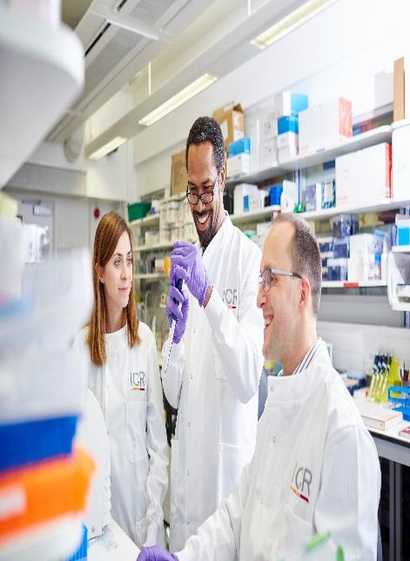
Scientific Officer –Evolutionary Immunogenomics
Candidate Information
January 2026

The Institute of Cancer Research

About our organisation
We are one of the world’s most influential cancer research institutes with an outstanding record of achievement dating back more than 100 years. We are world leaders in identifying cancer genes, discovering cancer drugs and developing precision radiotherapy. Together with our hospital partner The Royal Marsden, we are rated in the top four centres for cancer research and treatment worldwide.
As well as being a world-class institute, we are a college of the University of London. We came top in the league table of university research quality compiled from the Research Excellence Framework (REF 2014).
We have charitable status and rely on support from partner organisations, charities, donors and the general public.
We have more than 1000 staff and postgraduate students across three sites – in Chelsea and Sutton.

Evolutionary Immunogenomics and Radiotherapy Response Team

The Evolutionary Immunogenomics team investigates how immune-mediated evolutionary pressures shape tumour genomes and influence response to cancer therapies. The group focuses on immunoediting as a central evolutionary process, leading to the coexistence of immune-edited antigen-poor clones and immune-escaped antigen-rich tumours.

The team excels in computational biology and bioinformatics closely coupled to cancer genomics data. We integrate bespoke multi-omic analyses from in-house laboratory synthesised datasets with public datasets to elucidate why cancer evolves and what are the driver mutations behind it.

This position sits within an interdisciplinary programme analysing large-scale cancer cohorts (e.g, Hartwig) to understand tumour antigenicity, immune dynamics, and transcriptomics aberrations. By integrating whole-exome sequencing, transcriptomics, RNA-seq analysis, HLA typing, neoantigen prediction, T-cell receptor profiling, and computational biomarker discovery, the team aims to identify non - canonical drivers which are immunogenomic signatures of tumor evasion and immunotherapy resistance.

The research combines computational cancer evolution, immunogenomics, and translational oncology, with strong links to metastatic datasets and experimental laboratories. Our ideal candidates will have previous interdisciplinary experience, a strong track record in bioinformatics pipeline development and a keen interest in cancer evolution, transcriptomics and genomics. Senior scientists will provide full training in new techniques, and support will be available for attending training courses and appropriate academic

meetings.

Our mission
is to make the discoveries that defeat cancer.

Our mission
is to make the discoveries that defeat cancer.

Our values

The ICR has a highly skilled and committed workforce, with a wide variety of roles, each requiring different skills. But whether you work as a researcher, or work as part of our corporate team, your work and behaviour is underpinned by these six values. They are what bring us together as one team - as 'One ICR'.

Pursuing excellence
We aspire to excellence in everything we do, and aim to be leaders in our field.

Acting with Integrity
We promote an open and honest environment that gives credit and acknowledges mistakes, so that our actions stand up to scrutiny.

Valuing all our people
We value the contribution of all our people, help them reach their full potential, and treat everyone with kindness and respect.

Working together
We collaborate with colleagues and partners to bring together different skills, resources and perspectives.


Leading innovation
We do things differently in ways that no one else has done before, and share the expertise and learning we gain.

Making a difference
We all play our part, doing a little bit more, a little bit better, to help improve the lives of people with cancer.


Our values set out how each of us at the ICR, works together to
meet our mission – to make the discoveries that defeat cancer. They summarise our desired behaviours, attitudes and culture –
how we value one another and how we take pride in the work we
do, to deliver impact for people with cancer and their loved ones.”
Professor Kristian Helin
Chief Executive

Department / division: | Cancer Biology
Pay grade / staff group: | Scientific Professional
Hours / duration: | Full time (35 hours per week), Monday to Friday. Fixed term contract for 1 year with the possibility to extend dependant on further funding.
Reports to: | Dr Luis Zapata, Group Leader
Main purpose of the job: | To lead computational immunogenomics analyses in the Evolutionary Immunogenomics team, developing and maintaining automated pipelines using R, Python, shell and slurm jobs.

Key Duties and Responsibilities

Candidate will play a key role to support the computational biology team within the lab in the processing of sequencing data generated from patients with Breast Cancer
The post holder will perform computational analyses of data existing or produced within the laboratory, together with the analyses of public datasets.
Provide hands-on support to team members for debugging complex bioinformatics workflows and generating publication-ready results.
Maintain code repositories (Git-hub), audit genomic databases,
To attend and participate in Centre’s academic activities, e.g. laboratory and journal club meetings, research group meetings and weekly seminars.
Work in a flexible but organised manner to meet objectives/deadlines and be able to sequentially work on different projects
Ensure accurate recording, analysis and interpretation of data, in collaboration with the Team Leader
Take an interest in the general literature including scientific papers relevant to the work of the team and effectively ensure discussion with other team members including presentation of results
To attend and participate in Centre’s academic activities, e.g. journal club meetings, research group meetings and weekly seminars.

General

All staff must ensure that they familiarise themselves with and adhere to any ICR policies that are relevant to their work and that all personal and sensitive personal data is treated with the utmost confidentiality and in line with the General Data Protection Regulations
Any other duties that are consistent with the nature and grade of the post that may be required.
To work in accordance with the ICR’s Values.
To promote a safe, healthy and fair environment for people to work, where bullying and harassment will not be tolerated.
This job description is a reflection of the present position and is subject to review and alteration in detail and emphasis in the light of future changes or development.

Occupational Health
Hepatitis B immunisation will be required for the role and can be arranged through the Institute’s Occupational Health Department prior to appointment.

Education and Knowledge
First degree in a biological science (1st or 2:1) | Essential
MSc/MRes/PhD in bioinformatics/cancer biology or equivalent experience | Desirable
Knowledge of Cancer Biology | Essential
Knowledge of Python, R, shell, HPC(cluster) | Desirable

Skills
Ability to perform advanced bioinformatics analysis of cancer genomes and Troubleshoot Slurm jobs, conda environments, Singularity containers, and tool failures. | Essential
Ability to perform statistical inference and/or machine learning analyses | Essential
Ability to analyse different types of datasets including genomics (WES/WGS), transcriptomics (RNA-seq), and single-cell RNA sequences (Cell Ranger/TCR) | Essential
Basic Computational biology skills and coding | Essential
Attention to detail and keeping appropriate records | Essential
Ability to meet deadlines whilst multitasking under pressure | Essential
Professional presentation skills with the ability to recognise and highlight key information | Essential
Ability to work effectively & efficiently, both independently & as part of a team | Essential
Enthusiasm to work in an interdisciplinary environment towards the goal of developing improved cancer therapeutics | Essential
Track record of completing projects and preparing reports/presentations/scientific papers | Desirable
Experience
Research experience of computational transcriptomics for precision oncology | Desirable
Knowledge of somatic evolution and/or cancer evolution | Essential
Ability to interpret the scientific literature and incorporate this into the project | Essential
Understanding of the research process | Desirable

We offer a fantastic working environment, great opportunities for
career development and the chance to make a real difference to defeat cancer. We aim to recruit and develop the best – the most outstanding scientists and clinicians, and the most talented professional and administrative staff.
The annual leave entitlement for full time employees is 28 days per annum on joining. This will increase by a further day after 2 years’ and
5 years' service.
Staff membership to the Universities Superannuation Scheme (USS)
is available. The USS is a defined benefit scheme and provides a
highly competitive pension scheme with robust benefits. The rate of contributions is determined by USS and details of the costs and benefits of this scheme can be found on their website. If staff are transferring from the NHS, they can opt to remain members of the NHS Pension Scheme.
We offer a range of family friendly benefits such as flexible working,
a parents’ group, and a maternity mentoring scheme. Other great benefits include interest free loans for discounted season tickets for travel and bicycle purchases, access to the NHS discounts website,
a free and confidential Employee Assistance Programme which offers
a range of well-being, financial and legal advice services, two staff restaurants, and access to a gym and sporting facilities at our
Sutton site.

Further information
You may contact Dr Luis Zapata for further information by emailing luis.zapata@icr.ac.uk. This job description is a reflection of the current position and is subject to review and alteration in detail and emphasis in the light of future changes or development.

