Clinical Trials Assistant
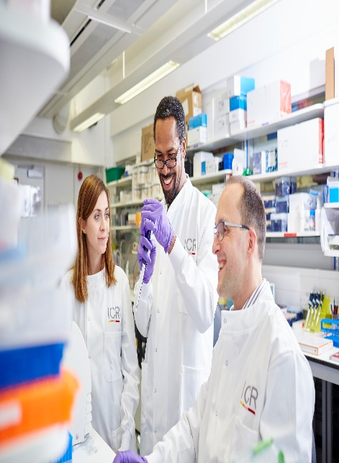

Candidate Information
March 2026

The Institute of Cancer Research

About our organisation
We are one of the world’s most influential cancer research institutes with an outstanding record of achievement dating back more than 100 years. We are world leaders in identifying cancer genes, discovering cancer drugs and developing precision radiotherapy. Together with our hospital partner The Royal Marsden, we are rated in the top four centres for cancer research and treatment worldwide.
As well as being a world-class institute, we are a college of the University of London. We came top in the league table of university research quality compiled from the Research Excellence Framework (REF 2014).
We have charitable status and rely on support from partner organisations, charities, donors and the general public.
We have more than 1000 staff and postgraduate students across three sites – in Chelsea and Sutton.

The Bob Champion Unit
The Bob Champion Unit lies within the Section of Radiotherapy and Imaging for urological cancers at the Institute of Cancer Research. The research is carried out in The Royal Marsden Hospital and all employees employed by the ICR but working within The Royal Marsden will have a contract of employment with the ICR but will also have an Honorary contract with The Royal Marsden (RMH).
The Bob Champion Unit is the research unit for the Uro-Oncology clinical trials which carries out research into prostate, bladder and testicular cancer. The Unit was named after a jockey called Bob Champion who was treated for testicular cancer at The Royal Marsden and then went onto win The Grand National. Since then he has been involved with fund raising for research into testicular cancer. Over the years the Unit has grown and evolved to include research into prostate and bladder cancer as well.
Currently we have over 30 clinical trials in various phases of recruitment and follow up, both academic and commercially sponsored trials. Our consultants or Principal Investigators have overall responsibility for the trials and have specific interest areas of research i.e. Prostate, bladder and testis. The research Unit comprises of Research Nnurses, Clinical Trial Manager, Clinical Trial Coordinators and Clinical Trial Assistants, each responsible for the management and support of a number of trials.
Our mission
is to make the discoveries that defeat cancer.

Our values
The ICR has a highly skilled and committed workforce, with a wide variety of roles, each requiring different skills. But whether you work as a researcher, or work as part of our corporate team, your work and behaviour is underpinned by these six values. They are what bring us together as one team - as 'One ICR'.

Pursuing excellence






We aspire to excellence in everything we do, and aim to be leaders in our field.

Acting with Integrity
We promote an open and honest environment that gives credit and acknowledges mistakes, so that our actions stand up to scrutiny.

Valuing all our people
We value the contribution of all our people, help them reach their full potential, and treat everyone with kindness and respect.

Working together
We collaborate with colleagues and partners to bring together different skills, resources and perspectives.

Leading innovation
We do things differently in ways that no one else has done before, and share the expertise and learning we gain.

Making a difference
We all play our part, doing a little bit more, a little bit better, to help improve the lives of people with cancer.


Our values set out how each of us at the ICR, works together to
meet our mission – to make the discoveries that defeat cancer. They summarise our desired behaviours, attitudes and culture –
how we value one another and how we take pride in the work we
do, to deliver impact for people with cancer and their loved ones.”
Professor Kristian Helin
Chief Executive

Department / division: | Radiotherapy and Imaging/Uro-Oncology
Pay grade / staff group: | Scientific Professional 7/ Research Management 1
Hours / duration: | Full time (35 hours per week), Monday to Friday.  Site based (Sutton).
Reports to: | Clinical Trial Manager
Main purpose of the job: | The Bob Champion Research Unit is responsible for a large number of urological clinical trials, both commercial and academic.  Primarily, the post holder will be part of a team working on MR Linac radiotherapy clinical trials supporting Clinical Trial Manager.  The post holder will also have general data and administrative duties supporting wider BCU research team, and specific responsibilities for two or more medicinal trials.
Job description
Duties and responsibilities:

CLINICAL TRIAL RESPONSIBILITIES

To provide support to the clinical research team - Clinical Trial Manager, Research Nurses/Clinical Trial Coordinators with study administration to ensure the efficient and successful delivery of clinical trials and other studies according to Good Clinical Practice (GCP), standard operating procedures (SOPs), trust policies and all applicable regulations and governance structures.
To ensure timely and accurate collection, coordination and entry of clinical trial data into appropriate database systems and ensure this is performed to the required standards of the current EU, UK and FDA legislation, Trust SOPs and Sponsor contractual obligations.
To work with the MR Linac radiographers and clinical team to ensure prompt resolution of data queries.
To design and implement tools and guidance for clinical trial data capture.
To regularly report on data entry status to ensure deadlines are met for interim and final analysis.
To represent the Data Management team at research meetings.
Support staff with the management of essential trial documentation (site file management, amendment documentation, capacity and capability review etc).
Collate curriculum vitae and training records for research staff for sponsors and managers of clinical trials (as required)
To prepare and facilitate the archiving of essential clinical trial documents and source data as per Trust SOPs.
To assist with the organisation of site visits by clinical trial monitors.
To attend unit research meetings, prepare information for meetings and undertake minute taking as required.
Act as a point of contact for trial sponsors and to communicate directly with them regarding data queries, monitoring visits and other enquiries relevant to the trial and research team.
Ensure that scans are uploaded to trial specific electronic portals where required.
Order lab supplies and courier services according to study requirements. Maintain records of lab supplies and stock levels, as required
Management of a small portfolio of low risk studies in the unit (as applicable)
Tissue tracking using RMH systems (as applicable)

Confidentiality

All information concerning patients and staff must be held in the strictest confidence and may not be divulged to any unauthorised person at any time, unless to do so is in the best interest of the individual. In this instance, a Senior Team Member would appropriately advise the post holder
Computer data should only be accessed if this has been authorised and is necessary as part of your work

General

All staff must ensure that they familiarise themselves with and adhere to any ICR policies that are relevant to their work and that all personal and sensitive personal data is treated with the utmost confidentiality and in line with the General Data Protection Regulations
Any other duties that are consistent with the nature and grade of the post that may be required.
Develop extensive knowledge of, and comply at all times, with the EU and UK Legislation for clinical trial conduct, RM Trust Level SOPs and local procedures
Work in a flexible manner and be organised, meeting objectives and deadlines
To work in accordance with the ICR’s Values.
To promote a safe, healthy and fair environment for people to work, where bullying and harassment will not be tolerated.
To be responsible for maintaining own professional development and be aware of current practices and future developments
This job description is a reflection of the present position and is subject to review and alteration in detail and emphasis in the light of future changes or development.

Education and Knowledge
Educated to A level or equivalent | Essential
Administration and computing | Essential
Interest in medical environment and clinical trials | Essential
Knowledge of medical terminology | Desirable
Knowledge of clinical research including GCP, Research Governance and European Clinical Trials Directive | Desirable

Skills
Person specification
Good IT skills, proficient with the use of MS Office applications | Essential
Excellent organisational skills | Essential
Good attention to detail | Essential
Database Management | Essential
Team working | Essential
Excellent communication skills | Essential

Experience
Background in health care environment | Desirable
Data management and data entry | Desirable
Clinical trials experience | Desirable
Clinical trials training ICH/GCP | Desirable

We offer a fantastic working environment, great opportunities for
career development and the chance to make a real difference to defeat cancer. We aim to recruit and develop the best – the most outstanding scientists and clinicians, and the most talented professional and administrative staff.
The annual leave entitlement for full time employees is 28 days per annum on joining. This will increase by a further day after 2 years’ and
5 years' service.
Staff membership to the Universities Superannuation Scheme (USS)
is available. The USS is a defined benefit scheme and provides a
highly competitive pension scheme with robust benefits. The rate of contributions is determined by USS and details of the costs and benefits of this scheme can be found on their website. If staff are transferring from the NHS, they can opt to remain members of the NHS Pension Scheme.
We offer a range of family friendly benefits such as flexible working,
a parents’ group, and a maternity mentoring scheme. Other great benefits include interest free loans for discounted season tickets for travel and bicycle purchases, access to the NHS discounts website,
a free and confidential Employee Assistance Programme which offers
a range of well-being, financial and legal advice services, two staff restaurants, and access to a gym and sporting facilities at our
Sutton site.

Further information
This job description is a reflection of the current position and is subject to review and alteration in detail and emphasis in the light of future changes or development.
Benefits

