Postdoctoral Training Fellows
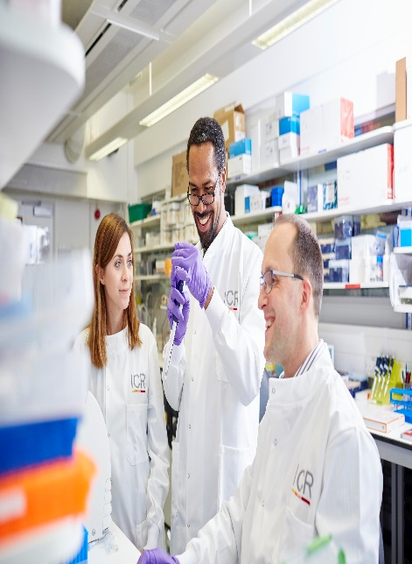

Epigenetics and Cancer
Start date: November 2026 or as agreed.

Epigenetics and Cancer Team, Division of Cell and Molecular Biology, Chelsea, London
The Epigenetics and Cancer team, directed by Professor Kristian Helin, investigates fundamental mechanisms that govern biological processes and explore how their disruption contributes to cancer. Our ultimate goal is to translate this research into new therapeutic strategies for cancer patients, while advancing our understanding of transcription, stem cell identity, and cellular differentiation.
Our work centres on the role of chromatin-associated proteins in regulating gene expression and cell-fate decisions. To pursue this, we draw on a broad toolkit spanning biochemistry, cell biology, genetics — including mouse models — and high-throughput screening approaches to uncover novel therapeutic targets.
We are looking for Postdoctoral Training Fellows to join the team. Successful applicants will lead projects exploring either the mechanistic basis of epigenetic regulation in gene expression and cell fate, or the role of these processes in blood cancers — or both. Fellows will become part of a close-knit, collaborative team that values rigorous scientific debate and thrives at the cutting edge of the field.
The team is based within the Cancer Biology Division at the ICR's Chester Beatty Laboratories in Chelsea, London. We benefit from a supportive research culture and world-class facilities across cell and molecular biology, next-generation sequencing, structural biology, and mouse genetics. The ICR's rich multidisciplinary environment means you'll be regularly exposed to outstanding research and ideas from across the scientific spectrum.

The Institute of Cancer Research
Our mission
is to make the discoveries that defeat cancer.

About our organisation
We are one of the world’s most influential cancer research institutes with an outstanding record of achievements dating back more than 100 years. We are world leaders in identifying cancer genes, discovering cancer drugs and developing precision radiotherapy. Together with our hospital partner The Royal Marsden, we are rated in the top four centres for cancer research and treatment worldwide.
As well as being a world-class institute, we are a college of the University of London. We came top in the league table of university research quality compiled from the last Research Excellence Framework.
We have charitable status and rely on support from partner organisations, charities, donors and the general public.
We have more than 1000 staff and postgraduate students across our sites – in Chelsea and Sutton.

Our values
The ICR has a highly skilled and committed workforce, with a wide variety of roles, each requiring different skills. But whether you work as a researcher, or work as part of our corporate team, your work and behaviour is underpinned by these six values. They are what bring us together as one team - as 'One ICR'.

Pursuing excellence






We aspire to excellence in everything we do, and aim to be leaders in our field.

Acting with Integrity
We promote an open and honest environment that gives credit and acknowledges mistakes, so that our actions stand up to scrutiny.

Valuing all our people
We value the contribution of all our people, help them reach their full potential, and treat everyone with kindness and respect.

Working together
We collaborate with colleagues and partners to bring together different skills, resources and perspectives.

Leading innovation
We do things differently in ways that no one else has done before, and share the expertise and learning we gain.

Making a difference
We all play our part, doing a little bit more, a little bit better, to help improve the lives of people with cancer.


Our values set out how each of us at the ICR, works together to
meet our mission – to make the discoveries that defeat cancer. They summarise our desired behaviours, attitudes and culture –
how we value one another and how we take pride in the work we
do, to deliver impact for people with cancer and their loved ones.”
Professor Kristian Helin
Chief Executive
Department / division: | Cancer Biology
Pay grade / staff group: | Postdoctoral Training Fellow. Starting salary will be dependent on previous experience.
Hours / duration: | Full time (35 hours per week), Monday to Friday. Fixed term contract for 3 years
Reports to: | Professor Kristian Helin, ICR, CEO
Main purpose of the job: | To carry out research on epigenetics and cancer.
Job description
Duties and responsibilities:

To design and perform experiments appropriate for the scientific projects of the PDTF
To ‘stay on top’ of the published literature relevant for the scientific project of the PDTF
Present data at lab meetings, journal clubs and conferences.
Keep accurate and accessible records of experiments and data.
To be part of a collaborative team

General:

All staff must ensure that they familiarise themselves with and adhere to any ICR policies that are relevant to their work and that all personal and sensitive personal data is treated with the utmost confidentiality and in line with the General Data Protection Regulations
Any other duties that are consistent with the nature and grade of the post that may be required.
To work in accordance with the ICR’s Values.
To promote a safe, healthy and fair environment for people to work, where bullying and harassment will not be tolerated.
This job description is a reflection of the present position and is subject to review and alteration in detail and emphasis in the light of future changes or development.

Workforce Agreement for Postdoctoral Training Fellows:

The ICR has a workforce agreement stating that Postdoctoral Training Fellows can only be employed for up to 7 years as PDTF at the ICR, providing total postdoctoral experience (including previous employment at this level elsewhere) does not exceed 10 years

Education and Knowledge
PhD in biology or other similar subject* - as a minimum requirement candidates must have submitted their thesis by the start date of their employment and awarded their PhD within the six month probationary period. | Essential
Knowledge of haematology | Desirable
Knowledge of molecular biology | Essential
Knowledge about epigenetics/chromatin | Essential

Skills
Person specification
Excellent organisation skills; ability to plan and prioritise work | Essential
Ability to work as part of a team – a “team player” | Essential
Good observation skills, attention to detail and ability to keep appropriate records | Essential
Good communication skills | Essential
Excellent computer skills | Essential
Motivated and enthusiastic, | Essential
Willingness to learn and apply newly acquired knowledge | Essential
Ability to multi-task | Essential

Experience
Experience in molecular biology techniques (recombinant DNA, cloning) | Essential
Experience in cell biology techniques of mammalian cells (tissue culture, transfection methods, microscopy). | Essential
Experience in biochemistry (protein purifications, protein-protein interaction analysis, protein-DNA interaction analysis). | Essential
Basic experience in computational biology (R or Python) and bioinformatics | Essential
Experience in mouse genetics | Desirable
Experience in haematology | Desirable

We offer a fantastic working environment, great opportunities for
career development and the chance to make a real difference to defeat cancer. We aim to recruit and develop the best – the most outstanding scientists and clinicians, and the most talented professional and administrative staff.
The annual leave entitlement for full time employees is 28 days per annum on joining. This will increase by a further day after 2 years’ and
5 years' service.
Staff membership to the Universities Superannuation Scheme (USS)
is available. The USS is a defined benefit scheme and provides a
highly competitive pension scheme with robust benefits. The rate of contributions is determined by USS and details of the costs and benefits of this scheme can be found on their website. If staff are transferring from the NHS, they can opt to remain members of the NHS Pension Scheme.
We offer a range of family friendly benefits such as flexible working,
a parents’ group, and a maternity mentoring scheme. Other great benefits include interest free loans for discounted season tickets for travel and bicycle purchases, access to the NHS discounts website,
a free and confidential Employee Assistance Programme which offers
a range of well-being, financial and legal advice services, two staff restaurants, and access to a gym and sporting facilities at our
Sutton site.

Further information
You may contact Kristian Helin for further information by emailing kristian.helin@icr.ac.uk. This job description is a reflection of the current position and is subject to review and alteration in detail and emphasis in the light of future changes or development.
Benefits

