Scientific Officer - In Vivo biology
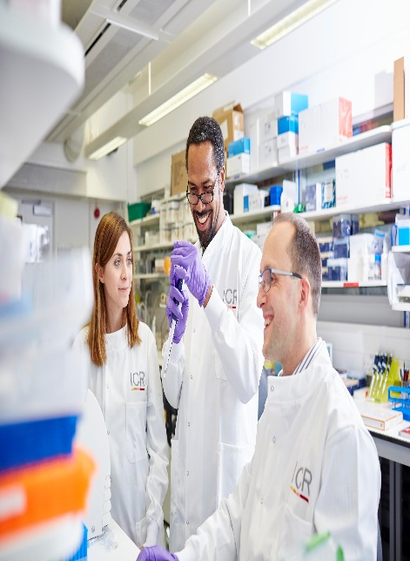

In Vivo Pharmacology

March 2026

The Institute of Cancer Research
About our organisation
We are one of the world’s most influential cancer research institutes with an outstanding record of achievement dating back more than 100 years. We are world leaders in identifying cancer genes, discovering cancer drugs and developing precision radiotherapy. Together with our hospital partner The Royal Marsden, we are rated in the top four centres for cancer research and treatment worldwide. As well as being a world-class institute, we are a college of the University of London. We are consistently in the top performing universities in the league table of university research quality complied from Research Excellence Framework (REF 2014 &2021).
We have charitable status and rely on support from partner organisations, charities, donors and the general public.
We have more than 1000 staff and postgraduate students across three sites – in Chelsea and Sutton.

About our team
Under UK law, animals can only be used for research if there is no appropriate alternative. All our research proposals are thoroughly assessed before approval to ensure that there is no alternative to the use of animals, and that the studies will provide valuable information that will ultimately help cancer patients.
The ICR is strongly committed to the highest standards of animal welfare in all research studies, and has led the development of best practice in this area. We also support the principles of the 3Rs – replacement, refinement and reduction of use of animals for research – and are working to develop alternative experimental techniques.

The In Vivo Pharmacology team provides in vivo support for all projects within the Centre for Cancer Drug Discovery. The team carries out critical proof-of-principle intervention studies and provides the essential pharmacological assays required to guide target validation in addition to the optimisation and selection of new drug candidates. Importantly, these experiments include the demonstration of drug effects in vivo, biomarker discovery and therapy studies all of which underpin the drug discovery programs across the portfolio. The team works across a wide range of tumour models, including human tumour xenografts models (both cell line- and patient-derived xenografts), genetically engineered mouse models and organoid based models. The team is also highly experienced in preclinical metastatic models. The team has specialised skills to develop and implement novel models, and supporting the design and implementation of studies, all whilst complying with increasingly complex Home Office regulations.

About this Position
We seek a dedicated early career in vivo scientist. The central aim of this position is to assist in the undertaking of in vivo technical work, playing a key role in supporting a variety of in vivo experiments and laboratory approaches. You will be an in vivo scientist with a basic knowledge and experience of in vivo techniques.
Your responsibilities will include monitoring animal welfare, carrying out animal procedures, maintaining detailed records. This position offers an excellent opportunity for an early career in vivo scientist with a passion for in vivo science, and animal welfare. We offer full training to gain a home office PIL, for more technical procedures to the right candidate.
There will occasionally be the need for out of hours work to ensure Home office compliance, and the needs of the projects are met.
The successful candidate will be a motivated individual with a strong background in animal welfare and husbandry in a research setting.
We highly value diversity and encourage candidates from all backgrounds to apply.

This position is offered on a non-time limited contract. Starting salary is in the range of £31,445- £33,100 per annum depending on experience

The ICR has a highly skilled and committed workforce, with a wide variety of roles, each requiring different skills. But whether you work as a researcher, or work as part of our corporate team, your work and behaviour is underpinned by these six values. They are what bring us together as one team - as 'One ICR'.

Pursuing excellence






We aspire to excellence in everything we do and aim to be leaders in our field.

Acting with Integrity
We promote an open and honest environment that gives credit and acknowledges mistakes, so that our actions stand up to scrutiny.
Valuing all our people
We value the contribution of all our people, help them reach their full potential, and treat everyone with kindness and respect.

Working together
We collaborate with colleagues and partners to bring together different skills, resources and perspectives.

Leading innovation
We do things differently in ways that no one else has done before and share the expertise and learning we gain.
Making a difference
We all play our part, doing a little bit more, a little bit better, to help improve the lives of people with cancer.
Our mission
is to make the discoveries that defeat cancer.

Department / division: | Centre for Cancer Drug Discovery/Division of Cancer Therapeutics
Pay grade / staff group: | Scientific Officer
Hours / duration: | Full time (35 hours per week), Monday to Friday. This position is offered for 18 months in the first instance with ability to extend subject to funding. Some out of hours requirement.
Reports to: | Alexis De Haven Brandon
Main purpose of the job: | To provide in vivo technical support to all projects across the CCDD
Job description
Duties and responsibilities:

Support the Drug Discovery programs

Assist the team in using cell line-derived and patient-derived xenograft models and genetically engineered mouse models to validate targets, assess tumour development, response to treatment, and biomarker changes.
Assist in performing in vivo procedures including:
- Welfare checks
- Tumour monitoring
- Dosing (oral, Intravenous, intraperitoneal, subcutaneous)
- Blood and tissue collection
- Necropsy and tissue processing

Prepare results for presentation – have a good Microsoft computer literacy.
Monitor animal health and tumour growth, maintaining accurate records and ensuring compliance with ethical and regulatory standards.

Comply with the regulatory framework

Ensure compliance with ICR and national regulations on ethics as relevant to the research programme.
Ensure that work conforms to the requirements of COSHH, Local Rules for Health and Safety, Home Office regulations and other Codes of Practice as required by the ICR Safety Policy.

Education and Knowledge
BSc in life sciences/or equivalent | E
Holds Home Office Personal licence PIL A, B, C | D
Broad-based knowledge of animal welfare within a research setting | E
General knowledge of cancer and its biology | D

General
Person specification
Highly enthusiastic and motivated, to make the discoveries that defeat cancer. | E
Ability to work both independently and as part of a team. | E
Willingness to continue ongoing training, learn new techniques. | E
Willingness to occasionally work out of hours. | E
High degree of integrity and understanding of the need for confidentiality surrounding drug discovery programmes. | E
Knowledge of Home Office regulations. | D

Skills
Person specification
Ability to assist in the execution of in vivo biological studies to a standard of international excellence and the highest ethical standards. To include welfare monitoring, tumour measuring, and record keeping. | E
Demonstrable ability to relate to and collaborate with colleagues within the team and in other departments/teams. | E
Ability to work both independently and as part of a team. | E
Ability to organise and prioritise own workload to meet deadlines. | E
Knowledge of in vivo techniques within the oncology field. | D
Knowledge and experience of in vivo biomarker discovery in support of drug development. | D

Experience
At least a year in an in vivo research setting with rodents. | E
Proven experience in husbandry, welfare monitoring and animal handling. | E
Experience in animal models of cancer. | D
Experience of oncology drug discovery in collaboration or within the pharmaceutical or biotechnology industry. | D
Experience of in vivo imaging in an oncology setting. | D

We offer a fantastic working environment, great opportunities for
career development and the chance to make a real difference to defeat cancer. We aim to recruit and develop the best – the most outstanding scientists and clinicians, and the most talented professional and administrative staff.
Benefits
The annual leave entitlement for full time employees is 28 days per annum on joining. This will increase by a further day after 2 years’ and
5 years' service.
Staff membership to the Universities Superannuation Scheme (USS)
is available. The USS is a defined benefit scheme and provides a
highly competitive pension scheme with robust benefits. The rate of contributions is determined by USS and details of the costs and benefits of this scheme can be found on their website. If staff are transferring from the NHS, they can opt to remain members of the NHS Pension Scheme.
We offer a range of family friendly benefits such as flexible working,
a parents’ group, and a maternity mentoring scheme. Other great benefits include interest free loans for discounted season tickets for travel and bicycle purchases, access to the NHS discounts website,
a free and confidential Employee Assistance Programme which offers
a range of well-being, financial and legal advice services, two staff restaurants, and access to a gym and sporting facilities at our
Sutton site.

Further information
You may contact Alexis De Haven Brandon for further information by emailing Alexis.dehavenbrandon@icr.ac.uk. This job description is a reflection of the current position and is subject to review and alteration.

