Analytical Scientist in Bioinformatics and Genomics
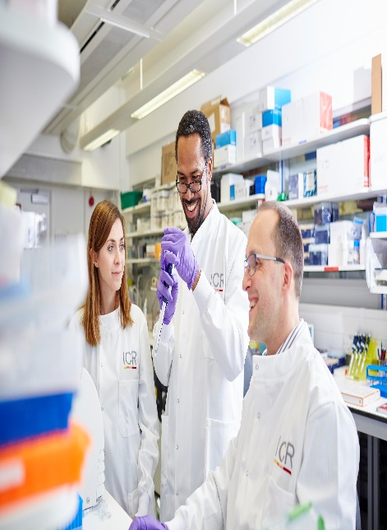

Candidate Information
April 2026

The Institute of Cancer Research
Description of the role
This position is based in the Data Science team led by Dr Syed Haider at the ICR in Chelsea, London.
We are seeking a highly motivated analytical scientist with experience in the application and deep understanding of genomic and imaging software to join the Breast Cancer Data Science Group at the Breast Cancer Now Centre (ICR, South Kensington site, London). We employ cutting-edge data-mining techniques in collaboration with experimental investigators to identify new molecular markers of breast cancer. Your work will focus on (however not limited to) the development and deployment of genomic pipelines on HPC and cloud trusted research environments (TREs). Further, you will also analyse and interpret outputs from these pipelines to inform experimental design and direction of research.
The successful candidate will be responsible for the development and maintenance of bioinformatics pipelines for DNA, RNA and single cell spatial imaging assays. While the primary responsibilities include development and maintenance of existing bioinformatics pipelines with focus on the interpretation of DNA alterations, the successful candidate will have opportunities to extend our infrastructure with cutting-edge technologies and green algorithms. Knowledge and experience of a workflow management system (e.g. nextflow) is highly desirable. We work in a multidisciplinary collaborative environment and therefore the successful candidate is expected to play a key role in liaising with clinical and wet-lab scientists, as well as contribute towards the write up of research results in a collaborative manner.

About our organisation
We are one of the world’s most influential cancer research institutes with an outstanding record of achievement dating back more than 100 years. We are world leaders in identifying cancer genes, discovering cancer drugs and developing precision radiotherapy. Together with our hospital partner The Royal Marsden, we are rated in the top four centres for cancer research and treatment worldwide.
As well as being a world-class institute, we are a college of the University of London. We came top in the league table of university research quality compiled from the Research Excellence Framework (REF 2014).
We have charitable status and rely on support from partner organisations, charities, donors and the general public. We have more than 1000 staff and postgraduate students across three sites – in Chelsea and Sutton.
About the team
The Breast Cancer Now Toby Robins Research Centre at the ICR is the first centre in the UK entirely devoted to breast cancer research. Our goal is to advance research into the causes, diagnosis and treatment of breast cancer. It is located in state-of-the-art laboratory space, with excellent research facilities and funding.
The Breast Cancer Data Science Team is an interdisciplinary group of researchers (~15) who are experts in high-throughput data analyses, machine learning/AI and software engineering. We work in a highly dynamic and collaborative environment focussing on the identification of molecular markers of breast cancer by interrogating genomic, epigenomic and transcriptomic datasets profiled using bulk as well as single-cell assays. In particular, we are interested in the application and development of bioinformatics methods to help understand the molecular basis of treatment resistant breast cancers.
Applicants should hold a PhD (or equivalent experience) in a computational/numerical subject, have programming and scripting experience, possess basic knowledge of biology and must be passionate about science.
The starting salary is within the range of £39,805 - £50,862 p.a. inclusive, based on relevance of skills and experience. This position will be offered on a fixed-term 3 year contract in the first instance.
In addition to annual performance related pay awards, the salary scales are reviewed annually to consider cost of living increases. The position is based at the ICR site in Chelsea.
Annual leave entitlement is 28 days per annum. There is an additional entitlement to 8 bank/public holidays and 3 ICR-set privilege days.

Our values
Our mission
is to make the discoveries that defeat cancer.

The ICR has a highly skilled and committed workforce, with a wide variety of roles, each requiring different skills. But whether you work as a researcher, or work as part of our corporate team, your work and behaviour is underpinned by these six values. They are what bring us together as one team - as 'One ICR'.

Pursuing excellence






We aspire to excellence in everything we do, and aim to be leaders in our field.

Acting with Integrity
We promote an open and honest environment that gives credit and acknowledges mistakes, so that our actions stand up to scrutiny.

Valuing all our people
We value the contribution of all our people, help them reach their full potential, and treat everyone with kindness and respect.

Working together
We collaborate with colleagues and partners to bring together different skills, resources and perspectives.

Leading innovation
We do things differently in ways that no one else has done before and share the expertise and learning we gain.

Making a difference
We all play our part, doing a little bit more, a little bit better, to help improve the lives of people with cancer.


Our values set out how each of us at the ICR, works together to
meet our mission – to make the discoveries that defeat cancer. They summarise our desired behaviours, attitudes and culture –
how we value one another and how we take pride in the work we
do, to deliver impact for people with cancer and their loved ones.”
Professor Kristian Helin
Chief Executive

Department / division: | Division of Breast Cancer Research, Bioinformatics team
Pay grade / staff group: | Analytical Scientist (2)
Hours / duration: | Full time (35 hours per week), Monday to Friday. Fixed term contract for 3 years  The post-holder may be required to work outside of standard hours including being available for occasional evening meetings and for meetings involving overnight stays and overseas travel.
Reports to: | Dr Syed Haider
Main purpose of the job: | The postholder will work independently and as a part of a multi-disciplinary team of analytical scientists, to maintain and develop analytical pipelines for next generation sequencing and imaging datasets arising from clinical cohorts. The successful post holder will be involved in the experimental design, analysis, interpretation and scientific writing of results for high impact journals.
Job description
Duties and responsibilities:

- Automation and scripting of common analytical tasks using workflow management systems and deployment on HPC and TREs
- Analysis of high-throughput DNA, RNA and single-cell sequencing datasets
- Development of analysis methods for new platforms and technologies where necessary
- Statistical analysis using R programming language
- Liaise and collaborate with teams at the Breast Cancer Now Centre and ICR
- Reporting progress in analysis of projects to lab meetings
- Preparation of data/manuscripts for presentations and publications

General

All staff must ensure that they familiarise themselves with and adhere to any ICR policies that are relevant to their work and that all personal and sensitive personal data is treated with the utmost confidentiality and in line with the General Data Protection Regulations
Any other duties that are consistent with the nature and grade of the post that may be required
To work in accordance with the ICR’s Values
To promote a safe, healthy, and fair environment for people to work, where bullying and harassment will not be tolerated
This job description is a reflection of the present position and is subject to review and alteration in detail and emphasis in the light of future changes or development.

Education and Knowledge
Post-Graduate Qualification in bioinformatics, computational biology, biostatistics, computer science or in a related quantitative field (or equivalent experience) | Essential
Programming experience in R or Python or Perl | Essential
Basic knowledge of *NIX systems and shell scripting | Essential
Experience and knowledge of pipeline development | Essential
Basic knowledge of biology | Essential

Skills
Person specification
Ability to work independently, collaboratively and as a part of an interdisciplinary team | Essential
Ability to work accurately, with a strong attention to detail | Essential
Excellent interpersonal skills to facilitate liaison with colleagues and collaborators | Essential

Experience
Experience in preprocessing of Next Generation Sequencing data analysis | Essential
Experience in using *NIX systems and compute clusters | Essential

General
Interest in cancer research | Essential
Good data presentation skills | Essential
Excellent organisational skills | Essential
Ability to project a positive and professional image of the ICR-BCN both to ICR and at external events/conferences | Essential
Effective verbal and written communication | Essential
Committed to publish collaborative & independent research | Essential

We offer a fantastic working environment, great opportunities for
career development and the chance to make a real difference to defeat cancer. We aim to recruit and develop the best – the most outstanding scientists and clinicians, and the most talented professional and administrative staff.
The annual leave entitlement for full time employees is 28 days per annum on joining. This will increase by a further day after 2 years’ and
5 years' service.
Staff membership to the Universities Superannuation Scheme (USS)
is available. The USS is a defined benefit scheme and provides a
highly competitive pension scheme with robust benefits. The rate of contributions is determined by USS and details of the costs and benefits of this scheme can be found on their website. If staff are transferring from the NHS, they can opt to remain members of the NHS Pension Scheme.
We offer a range of family friendly benefits such as flexible working,
a parents’ group, and a maternity mentoring scheme. Other great benefits include interest free loans for discounted season tickets for travel and bicycle purchases, access to the NHS discounts website,
a free and confidential Employee Assistance Programme which offers
a range of well-being, financial and legal advice services, two staff restaurants, and access to a gym and sporting facilities at our
Sutton site.

Further information
You may contact Dr Syed Haider for further information by emailing syed.haider@icr.ac.uk This job description reflects the current position and is subject to review and alteration in detail and emphasis in the light of future changes or development.
Benefits

