Postdoctoral Training Fellow:
Telomere Biology
Candidate Information
January 2026

Department / division: | Telomere Biology group, Cell and Molecular Biology Division
Pay grade / staff group: | Postdoctoral Training Fellow
Hours / duration: | Full time (35 hours per week), Monday to Friday. Fixed term contract for 2 years with room for extension
Reports to: | Dr Max Douglas, Group Leader
Job description

Context
Understanding the complexes and factors that protect and process telomeres is central to the ICR’s mission of making the discoveries that defeat cancer.
Our mission
is to make the discoveries that defeat cancer.

Main purpose of the job

To use a multidisciplinary approach that builds on our recent work (Eickhoff et al, Nature 2025) to examine the factors that bind and process telomeric ends.

Further information
You may contact Max Douglas for further information by emailing max.douglas@icr.ac.uk. This job description is a reflection of the current position and is subject to review and alteration in detail and emphasis in the light of future changes or development.

Duties and responsibilities

Key duties
Purify DNA end binding factors using recombinant systems including bacteria and baculovirus-infected insect cells.
Explore the assembly and regulation and these factors on telomeric and non-telomeric substrates using biochemical techniques.
Analyse complexes from this analysis in conjunction with the ICR EM facility with the aim of determining high resolution cryo-EM structures

Validate and test hypotheses from this work by performing genetic experiments in cultured human cells
Interact with the group leader and team members, fostering a positive working environment.
Take responsibility for the use and maintenance of items of specialised laboratory equipment.
Ensure that accurate records of all experimental data are maintained in our electronic notebook system.
Communicate to and discuss results with the rest of the telomere biology team
Present at lab meetings, journal clubs and seminars
Write drafts of publications arising from the work
Work in a flexible but organised manner to meet objectives/deadlines
Work independently and to consult when appropriate
Contribute to the supervision and training of junior staff

Workforce Agreement for Postdoctoral Training Fellows
The ICR has a workforce agreement stating that Postdoctoral Training Fellows can only be employed for
up to 7 years as PDTF at the ICR, providing total postdoctoral experience (including previous employment
at this level elsewhere) does not exceed 10 years.

General
All staff must ensure that they familiarise themselves with and adhere to any ICR policies that are relevant
to their work and that all personal and sensitive personal data is treated with the utmost confidentiality and
in line with the General Data Protection Regulations.
Any other duties that are consistent with the nature and grade of the post that may be required.
To work in accordance with the ICR’s Values.
To promote a safe, healthy and fair environment for people to work, where bullying and harassment will not be tolerated.

Person specification

Education and Knowledge
 | PhD in biochemistry, cell biology, molecular biology  or similar. | Essential
 | Strong publication record in molecular cell biology, biochemistry, biophysics or structural biology, as demonstrated by good first author publications | Essential
Knowledge of chromosome biology, telomeres and DNA replication |  | Desirable
Knowledge of genome stability and the eukaryotic cell cycle |  | Desirable

Skills
Proven ability to design and implement experiments | Essential
Proven ability to communicate research findings at academic conferences and meetings | Essential
Excellent oral and written communication skills | Essential
Proficient IT skills | Essential
Proven ability to purify recombinant proteins | Desirable
Expertise in negative stain and cryo-EM grid preparation, data collection and processing | Desirable
Proven ability to plan, organise and prioritise a busy workload | Essential
Ability to work effectively and efficiently, both independently and as part of a team | Essential
Ability to work to tight deadlines | Essential
Ability to work well under pressure without compromising output | Essential

Experience
Familiarity with biochemical techniques and experimental approaches. | Essential
Considerable experience in cell and molecular biology (including recombinant DNA techniques) | Essential
Experience working with in vitro reconstituted systems | Desirable
Experience in electron microscopy | Desirable

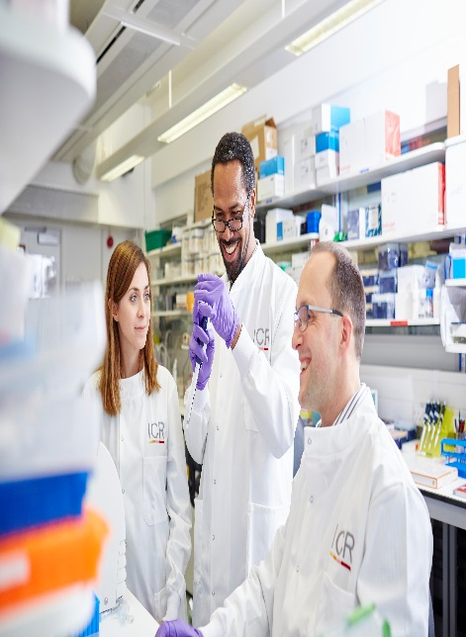
About our organisation

The Institute of Cancer Research, London, is one of the world’s most
influential cancer research institutions with an outstanding track record
of achievement dating back more than 100 years. Our mission is to
make the discoveries that defeat cancer.

As well as being one of the UK’s leading higher education institutions in
research quality and impact, the ICR is consistently ranked as one of
the world’s most successful for industry collaboration. As a member
institution of the University of London, we also provide postgraduate
higher education of international distinction.

We are also a charity and rely on the support of partner organisations,
funders, donors and the general public.

Read more to find out about our history, culture, and achievements, and
how our funders, supporters and partnerships help drive our work.

Our values
The ICR has a highly skilled and committed workforce, with a wide variety of roles, each requiring different skills. But whether you work
as a researcher, or work as part of our corporate team, your work and behaviour is underpinned by these six values. They are what bring us together as one team - as 'One ICR'.







Our values set out how each of us at the ICR, works together to
meet our mission – to make the discoveries that defeat cancer. They summarise our desired behaviours, attitudes and culture –
how we value one another and how we take pride in the work we
do, to deliver impact for people with cancer and their loved ones.”
Professor Kristian Helin
Chief Executive

