Postdoctoral Training Fellow:
Online Adaptive Radiotherapy (RT) Modelling
Candidate Information
September 2026

Department / division: | Radiotherapy Physics Modelling Team  Division of Radiotherapy & Imaging
Pay grade / staff group: | Postdoctoral Training Fellow
Hours / duration: | Full time (35 hours per week)  Monday to Friday  Onsite – Sutton campus  Fixed term contract for 3 years initially
Reports to: | Group Leader Radiotherapy Physics Modelling team
Job description

Context
The Radiotherapy Physics Modelling Team is part of the Joint Department of Physics (Institute of Cancer Research (ICR) & Royal Marsden NHS Foundation Trust (RMH)) and is primarily focused on the development and application of novel technology to further radiotherapy treatments. This includes novel treatment planning techniques, the development of new optimisation algorithms and using modern computer hardware to enable real-time online plan optimisation.
The post-doctoral training fellow will contribute to the development and clinical implementation of online adaptive RT on advanced treatment platforms (MR-Linac, C-arm linac and gantry-based treatment units) at RMH. The projected research is a part of a larger program of work funded by a CRUK program grant. The successful candidate will work in an interdisciplinary team of medical physicists, computer scientists and clinicians in the Joint Department of Physics at the ICR & RMH.
They will develop a framework for dynamic plan refinement in real-time for MR-guided RT, acceleration of automated, on-line adaptive treatment planning and devise strategies for quality assurance (QA) of real-time adapted RT. The final aim of this research is to demonstrate benefit of this cutting-edge technology for patients in collaboration with clinicians and industrial partners.

Our mission
is to make the discoveries that defeat cancer.

Main purpose of the job
- Develop a framework for dynamic plan refinement in real time for MR-guided RT, acceleration of automated, on-line adaptive treatment planning and devise strategies for quality assurance (QA) of real-time adapted RT.
- Support the pathway to first clinical implementation of the developed technology.
- Maintain and further improve the currently available tools for real-time adaptive RT and motion models at ICR/RMH.

Further information
You may contact Professor Uwe Oelfke, Head of the Joint Department of Physics for further information by emailing uwe.oelfke@icr.ac.uk This job description is a reflection of the current position and is subject to review and alteration in detail and emphasis in the light of future changes or development.

Key duties
Duties and responsibilities
Design a software framework for real-time adaptive therapy for MR-guided and CT-guided dose delivery systems. Explore all necessary interfaces between the in-house software and the necessary research interfaces provided by collaborators from industry
Work in collaboration with MR physicists to explore and find optimal image sequences for real-time adaptive RT.
Integrate motion models developed by collaboration partners into the software framework and research possible delivery adaption strategies using not only the tumour but also the organs at risk locations.
Design, develop, and modify (in collaboration with the mechanical workshop) phantoms to validate the developed software modules in terms of achievable accuracy for delivered doses.
Keep up to date with, and inform the team of, new developments in the relevant literature.
Ensure adequate record-keeping and documentation of all experiments and developed source code.
Key result areas
Develop clinical demonstrators for accelerated treatment planning, dynamic plan refinement during patient treatment and respective QA strategies.
Provide evidence (using phantoms and data acquired from patients undergoing standard treatment on the MR Linac and CT-guided systems) that the developed pipeline of real-time RT tools can be safely applied to patients in the future
Publish the results of the research in peer reviewed journals and present at national and international conferences

Other duties and responsibilities
Interact with members of the Radiotherapy Physics Modelling team.
Collaborate with the external academic and industrial partners.
Liaise with clinical staff including radiation oncologists, radiologists, radiographers, medical physicists and mechanical engineering staff.
Attend team and project meetings as required at different locations of ICR/RMH.
Present work at international conferences, in particular the ESTRO and MR in RT meetings.
Attend training courses as required and appropriate for the project.
Liaise with other teams working within the fields of radiotherapy and scientific computing within the ICR.
Ensure the development of hardware and software is supported by accurate and clear documentation and developed in such a way that other users can be trained to use and develop it.
Ensure the integrity and confidentiality of data collected as part of the project.
Mentor scientific staff, e.g. PhD students and undergraduates, in research projects related to radiotherapy. Support other team members in their research by engaging with their work and promoting a positive research ethos.

Workforce Agreement for Postdoctoral Training Fellows
The ICR has a workforce agreement stating that Postdoctoral Training Fellows can only be employed for
up to 7 years as PDTF at the ICR, providing total postdoctoral experience (including previous employment
at this level elsewhere) does not exceed 10 years.

General
All staff must ensure that they familiarise themselves with and adhere to any ICR (and where appropriate, Royal Marsden NHS Foundation Trust) policies that are relevant to their work and that all personal and sensitive personal data is treated with the utmost confidentiality and in line with the General Data Protection Regulations.
Any other duties that are consistent with the nature and grade of the post that may be required.
To work in accordance with the ICR’s Values.
To promote a safe, healthy and fair environment for people to work, where bullying and harassment will not be tolerated.

Person specification

Education and Knowledge
 | PhD* in Physics, Engineering, Informatics or a related discipline  *as a minimum requirement candidates must have submitted their thesis by the start date of their employment and be awarded their PhD within the six-month probationary period | Essential
 | Knowledge of radiotherapy physics, treatment planning, programming, relevant experimental methodology | Essential
Excellent knowledge and extended experience in the development of AI-based strategies and motion models applied in radiation oncology |  | Essential

Skills
Excellent experimental skills | Desirable
Ability to assimilate relevant information and initiate new areas of research | Essential
Coordinating, planning and executing research to a high standard | Essential
Good communication skills and the ability to foster collaborative projects | Essential

Experience
Radiotherapy treatment planning and optimisation algorithms | Essential
Proven track record of productive research/good publication record | Essential
System integration of software within a research device (hardware/software) | Essential
Development and application of research software for future translation into a medical product | Desirable
Familiarity with radiotherapy treatment workflows | Essential

General
Highly self-motivated and enthusiastic, with a keen desire to produce high quality scientific data | Essential
Excellent interpersonal skills with the ability to work flexibly and to establish effective working relationships as part of a team | Essential
Ability to think and work effectively & semi-independently | Essential
Ability to plan, organise & prioritise a busy workload | Desirable

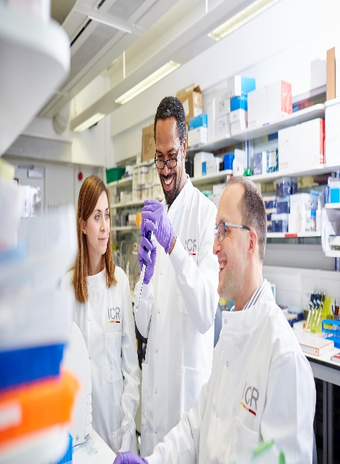
About our organisation

The Institute of Cancer Research, London, is one of the world’s most
influential cancer research institutions with an outstanding track record
of achievement dating back more than 100 years. Our mission is to
make the discoveries that defeat cancer.

As well as being one of the UK’s leading higher education institutions in
research quality and impact, the ICR is consistently ranked as one of
the world’s most successful for industry collaboration. As a member
institution of the University of London, we also provide postgraduate
higher education of international distinction.

We are also a charity and rely on the support of partner organisations,
funders, donors and the general public.

Read more to find out about our history, culture, and achievements, and
how our funders, supporters and partnerships help drive our work.

Our values
The ICR has a highly skilled and committed workforce, with a wide variety of roles, each requiring different skills. But whether you work
as a researcher, or work as part of our corporate team, your work and behaviour is underpinned by these six values. They are what bring us together as one team - as 'One ICR'.







Our values set out how each of us at the ICR, works together to
meet our mission – to make the discoveries that defeat cancer. They summarise our desired behaviours, attitudes and culture –
how we value one another and how we take pride in the work we
do, to deliver impact for people with cancer and their loved ones.”
Professor Kristian Helin
Chief Executive

