Postdoctoral Training Fellow:
Chromatin Biology and Epigenetics
Candidate Information
September 2026

Department / division: | Cell and Molecular Biology
Pay grade / staff group: | Postdoctoral Training Fellow
Hours / duration: | Full time (35 hours per week), Monday to Friday  Fixed term contract for 2 years in the first instance
Reports to: | Dr Alex Radzisheuskaya
Job description

Research context and opportunity
Our mission
is to make the discoveries that defeat cancer.
Epigenetic dysregulation is an important driver of cancer and developmental disease, yet we still have a limited understanding of how individual histone modifications regulate molecular and cellular phenotypes. Addressing this question is important both for understanding fundamental chromatin biology and for determining how epigenetic pathways might be targeted more effectively in disease.

Our research aims to understand how specific histone modifications regulate transcription, chromatin organisation and cellular identity in normal and disease contexts. By combining histone mutagenesis, inducible protein degradation and CRISPR-engineered models with genomic, epigenomic and functional approaches, we aim to establish causal relationships between individual histone modifications and their molecular and cellular effects.

The successful candidate will investigate these mechanisms in the context of acute myeloid leukaemia (AML), asking how altered histone acetylation contributes to changes in gene regulation and leukaemic cell state. The project will provide opportunities to work across chromatin biology, functional genomics and cancer biology, using complementary approaches to address mechanistic questions with relevance to disease.

We are looking for someone who is curious about mechanistic biology and enjoys thinking about how molecular changes lead to biological phenotypes. The postdoctoral researcher will have scope to develop their own ideas within the broader research programme and to take intellectual ownership of the project as it develops.

The group is based within the Division of Cell and Molecular Biology at the ICR's Chelsea site, a highly collaborative environment with expertise spanning chromatin and genome biology, cancer biology and structural biology. Researchers have access to state-of-the-art facilities and technology platforms, including genomics, flow cytometry, microscopy, proteomics and scientific computing. The group is supported by the UKRI, Blood Cancer UK and the ICR.

Main purpose of the job

The successful applicant will lead a research project investigating the role of histone acetylation in gene regulation and cell identity in acute myeloid leukaemia. They will use complementary molecular, genomic and functional approaches to define the mechanisms underlying these effects and contribute to the development of new research directions within the group.

Further information
You may contact Dr Alex Radzisheuskaya for further information by emailing alex.radzisheuskaya@icr.ac.uk. This job description is a reflection of the current position and is subject to review and alteration in detail and emphasis in the light of future changes or development.

Duties and responsibilities

Key duties
Conceiving, designing, and conducting experiments to address the aims of the project, and analysing and interpreting the results
Staying up to date with relevant literature and developments in the field
Contributing to the development of new research ideas and directions, and participating, where appropriate, in the preparation of research proposals and funding applications
Presenting research findings at laboratory meetings, institute-level events, and national and international conferences
Preparing manuscripts and publishing research findings in internationally recognised peer-reviewed journals
Establishing and pursuing collaborations within and outside the ICR
Contributing to the supervision, mentoring, and training of junior members of the laboratory
Reporting progress and discussing results with the team leader on a regular basis
Maintaining accurate and high-quality electronic laboratory records and contributing to the maintenance of the central laboratory inventory
Contributing to general laboratory duties, which are shared equitably among all members of the laboratory
Fostering a positive, inclusive, supportive, and collaborative laboratory environment

Workforce Agreement for Postdoctoral Training Fellows
The ICR has a workforce agreement stating that Postdoctoral Training Fellows can only be employed for
up to 7 years as PDTF at the ICR, providing total postdoctoral experience (including previous employment
at this level elsewhere) does not exceed 10 years.

General
All staff must ensure that they familiarise themselves with and adhere to any ICR policies that are relevant
to their work and that all personal and sensitive personal data is treated with the utmost confidentiality and
in line with the General Data Protection Regulations.
Any other duties that are consistent with the nature and grade of the post that may be required.
To work in accordance with the ICR’s Values.
To promote a safe, healthy and fair environment for people to work, where bullying and harassment will not be tolerated.

Person specification

Education and Knowledge
 | PhD (or near completion) in biochemistry, cell biology, molecular biology or a related discipline. | Essential
 | Evidence of research productivity, demonstrated through peer-reviewed publications, preprints, submitted manuscripts, or other relevant research outputs | Essential
Knowledge of epigenetics, chromatin biology and transcription regulation |  | Essential
Knowledge of cancer biology |  | Desirable

Skills & Experience
Ability to develop research ideas, formulate hypotheses, and contribute intellectually to the direction of the project | Essential
Proven ability to design, conduct, and troubleshoot experiments in a rigorous, timely, and efficient manner | Essential
Hands-on experience in mammalian cell culture and manipulation | Essential
Proficiency in a range of core molecular and cell biology techniques, such as molecular cloning, gene expression analysis, western blotting, immunostaining, flow cytometry and immunoprecipitation | Essential
Experience with CRISPR-based genome editing | Desirable
Experience with high-throughput genomic and transcriptomic approaches, such as ChIP-seq/CUT&RUN/CUT&Tag, RNA-seq and ATAC-seq | Desirable
Ability to analyse and interpret next-generation sequencing datasets | Desirable
Excellent written and oral communication skills, including the ability to present research findings clearly to scientific audiences | Essential
 | Essential
  Ability to work effectively both independently and collaboratively as part of a research team
 | Desirable
  Experience in supervising, mentoring, or training students or other junior researchers

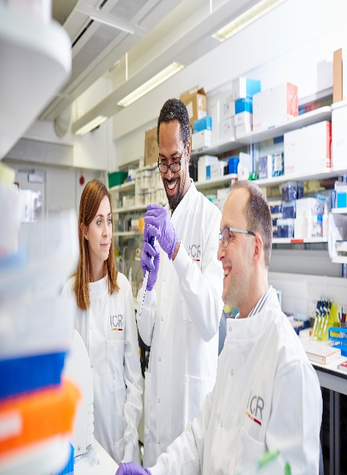
About our organisation

The Institute of Cancer Research, London, is one of the world’s most
influential cancer research institutions with an outstanding track record
of achievement dating back more than 100 years. Our mission is to
make the discoveries that defeat cancer.

As well as being one of the UK’s leading higher education institutions in
research quality and impact, the ICR is consistently ranked as one of
the world’s most successful for industry collaboration. As a member
institution of the University of London, we also provide postgraduate
higher education of international distinction.

We are also a charity and rely on the support of partner organisations,
funders, donors and the general public.

Read more to find out about our history, culture, and achievements, and
how our funders, supporters and partnerships help drive our work.

Our values
The ICR has a highly skilled and committed workforce, with a wide variety of roles, each requiring different skills. But whether you work
as a researcher, or work as part of our corporate team, your work and behaviour is underpinned by these six values. They are what bring us together as one team - as 'One ICR'.







Our values set out how each of us at the ICR, works together to
meet our mission – to make the discoveries that defeat cancer. They summarise our desired behaviours, attitudes and culture –
how we value one another and how we take pride in the work we
do, to deliver impact for people with cancer and their loved ones.”
Professor Kristian Helin
Chief Executive

