Scientific Officer – Analytical Chemist
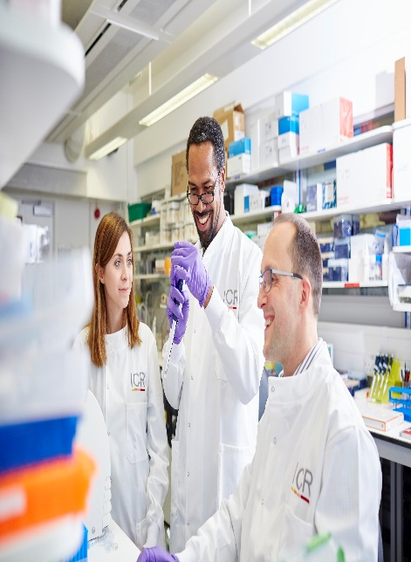

Candidate Information
December 2025/ January 2026

The Institute of Cancer Research

About our organisation
We are one of the world’s most influential cancer research institutes with an outstanding record of achievement dating back more than 100 years. We are world leaders in identifying cancer genes, discovering cancer drugs and developing precision radiotherapy. Together with our hospital partner The Royal Marsden, we are rated in the top four centres for cancer research and treatment worldwide.
As well as being a world-class institute, we are a college of the University of London. We came top in the league table of university research quality compiled from the Research Excellence Framework (REF 2014).
We have charitable status and rely on support from partner organisations, charities, donors and the general public.
We have more than 1000 staff and postgraduate students across three sites – in Chelsea and Sutton.

The Structural Chemistry Team
Structural Chemistry provides the Centre for Cancer Drug Discovery with analytical chemistry expertise, methodology, and tools for comprehensive structure elucidation that are mission critical for our drug discovery programmes. Dr Amin Mirza’s team offers expertise in NMR, mass spectrometry, chromatography, and molecular spectroscopy techniques applied to small molecule characterisation, separations & purifications, biomolecule & ligand interactions, and assay of physicochemical properties.

About the Scientific Officer position
The post holder will be based within the Structural Chemistry Team (Medicinal Chemistry 4). As part of a highly productive analytical facility at a world class cancer research institute, the role is to provide expertise in the fields of structural characterisation and physicochemical properties assay of potential new anticancer drugs.
​

Our mission
is to make the discoveries that defeat cancer.
Our mission
is to make the discoveries that defeat cancer.

Our values
The ICR has a highly skilled and committed workforce, with a wide variety of roles, each requiring different skills. But whether you work as a researcher, or work as part of our corporate team, your work and behaviour is underpinned by these six values. They are what bring us together as one team - as 'One ICR'.

Pursuing excellence






We aspire to excellence in everything we do, and aim to be leaders in our field.

Acting with Integrity
We promote an open and honest environment that gives credit and acknowledges mistakes, so that our actions stand up to scrutiny.

Valuing all our people
We value the contribution of all our people, help them reach their full potential, and treat everyone with kindness and respect.

Working together
We collaborate with colleagues and partners to bring together different skills, resources and perspectives.

Leading innovation
We do things differently in ways that no one else has done before, and share the expertise and learning we gain.

Making a difference
We all play our part, doing a little bit more, a little bit better, to help improve the lives of people with cancer.


Our values set out how each of us at the ICR, works together to
meet our mission – to make the discoveries that defeat cancer. They summarise our desired behaviours, attitudes and culture –
how we value one another and how we take pride in the work we
do, to deliver impact for people with cancer and their loved ones.”
Professor Kristian Helin
Chief Executive

Department / division: | Cancer Therapeutics
Pay grade / staff group: | Scientific Professional (SP7)
Hours / duration: | Full time (35 hours per week), Monday to Friday. Fixed term contract for 18 months
Reports to: | Dr Amin Mirza, Head of Structural Chemistry Facility
Main purpose of the job: | As part of a highly productive analytical facility at a world class cancer research institute, the role is to provide expertise in the fields of structural characterisation and physicochemical properties assay of potential new anticancer drugs.  The successful candidate will work on drug discovery projects where they will support and collaborate with medicinal chemists and biologists by providing scientific expertise and maintaining the Structural Chemistry Facility. Training on and supervision of mission critical analytical equipment is a key element of the role as is aid in interpretation of results obtained using a variety of spectroscopic techniques. The successful candidate will also support drug discovery programmes by developing methodology to address specific investigations.
Job description

Key Duties and Responsibilities

The post-holder will be laboratory based and work pro-actively under the supervision of a senior member of the team.
Provide expertise in the day-to-day maintenance, troubleshooting, and support of core LC, MS, and NMR instrumentation.
Responsible for training and resources for personnel for the safe practice of analytical techniques.
Provide interpretation and reporting of analytical data as required by drug discovery teams.
Provide expert physicochemical properties assays for drug discovery projects.
Develop methodology for separation or purification and characterisation (using LC with UV/MS) of small molecules, peptides, or proteins.
Aid in the set-up of new instrumentation and techniques in response to project requirements.
Ensure accurate recording, analysis and interpretation of data, in collaboration with colleagues.
Prepare reports of results for presentation at meetings.
Take an interest in the general literature including scientific papers relevant to the work of the team and effectively ensure discussion with other team members including presentation of results
Ensure that all work carried out conforms to the requirements of COSHH, ACGM, local safety guidelines and codes of practice as required by the ICR safety policy and Cancer Therapeutics Unit guidelines.
Maintain the laboratory and equipment in a safe, clean, and efficient condition.
Initiate purchase of and maintain laboratory consumable items for facility within budgetary limits
Work in an organised manner to meet objectives and deadlines.
Work effectively within multiple team environments.
Communicate effectively with other members of the Structural Chemistry team, drug-discovery project teams, and collaborating organisations/vendors as required.

General

All staff must ensure that they familiarise themselves with and adhere to any ICR policies that are relevant to their work and that all personal and sensitive personal data is treated with the utmost confidentiality and in line with the General Data Protection Regulations
Any other duties that are consistent with the nature and grade of the post that may be required.
To work in accordance with the ICR’s Values.
To promote a safe, healthy and fair environment for people to work, where bullying and harassment will not be tolerated.
This job description is a reflection of the present position and is subject to review and alteration in detail and emphasis in the light of future changes or development.

Education and Knowledge
An accredited first degree (or equivalent) in chemistry or biochemical sciences | Essential
Knowledge of analytical chemistry techniques | Essential
Post graduate degree or occupational experience with emphasis on analytical techniques | Desirable
Knowledge of the drug discovery process | Desirable

Skills
Person specification
Strong intellectual curiosity and commitment to successfully learn new research methodologies | Essential
Excellent communication skills and the ability to recognise and highlight key information | Essential
Ability to work within the guidelines of Data Protection and Good Laboratory Practice | Essential
Excellent organisation skills and proven ability to prioritise workload whilst under pressure | Essential
Enthusiasm to work in an interdisciplinary environment towards the goal of developing improved cancer therapeutics | Essential
Excellent observation skills, attention to detail, and ability to keep accurate records | Essential
Methodical approach to problem solving and troubleshooting | Essential
Excellent computer literacy – ability to use a diverse range of software (e.g. statistical to analytical processing) | Essential
Ability to work effectively & efficiently, both independently & as part of a team | Essential
Ability to meet deadlines, prepare scientific reports, and present data at  regular project meetings | Essential

Experience
Hands on experience of analytical techniques | Desirable
Experience of physicochemical properties determination or methodology development | Desirable
Experience of analytical chemistry software | Desirable
Experience of scripting or data science platforms | Desirable

We offer a fantastic working environment, great opportunities for
career development and the chance to make a real difference to defeat cancer. We aim to recruit and develop the best – the most outstanding scientists and clinicians, and the most talented professional and administrative staff.
The annual leave entitlement for full time employees is 28 days per annum on joining. This will increase by a further day after 2 years’ and
5 years' service.
Staff membership to the Universities Superannuation Scheme (USS)
is available. The USS is a defined benefit scheme and provides a
highly competitive pension scheme with robust benefits. The rate of contributions is determined by USS and details of the costs and benefits of this scheme can be found on their website. If staff are transferring from the NHS, they can opt to remain members of the NHS Pension Scheme.
We offer a range of family friendly benefits such as flexible working,
a parents’ group, and a maternity mentoring scheme. Other great benefits include interest free loans for discounted season tickets for travel and bicycle purchases, access to the NHS discounts website,
a free and confidential Employee Assistance Programme which offers
a range of well-being, financial and legal advice services, two staff restaurants, and access to a gym and sporting facilities at our
Sutton site.

Further information
You may contact Dr Amin Mirza for further information by emailing amin.mirza@icr.ac.uk. This job description is a reflection of the current position and is subject to review and alteration in detail and emphasis in the light of future changes or development.
Benefits

