Postdoctoral Training Fellow, Functional Proteomics
Candidate Information
December 2025

Department / division: | Division of Cell and Molecular Biology, Functional Proteomics Team and Protein Degradation Centre
Pay grade / staff group: | Postdoctoral Training Fellow
Hours / duration: | Full time (35 hours per week), Monday to Friday (Fixed term contract for 3 years)
Reports to: | Group Leaders (Prof. Jyoti Choudhary and Prof. Zoran Rankovic)
Job description

Context
The Post-doctoral Training Fellow will be part of the Functional Proteomics group and The Centre of Protein Degradation. The objective of this post is to develop innovative quantitative proteomics workflows for the characterization of targeted protein degradation and functions. This will involve collaborative research as well as development or optimisation of new proteomics methods. The post holder will undertake end-to-end analysis of a variety of sample types. The main analysis pipelines will include isobaric labelling and DIA protein quantification using cutting-edge instrumentation, characterization of post-translational modifications and downstream data processing and statistical analysis. The post holder is expected to work independently quickly and to communicate the results to the group as well as to collaborating ICR groups with follow up meetings making sure that they obtain a good understanding of the quantitative data and the technology used. The post holder will be required to represent the group in local or international conferences with oral or poster presentations. Training and supervision of new starters and collaborators to analysis pipelines is also among the important duties of the post holders. A strong candidate would be able to design, develop and publish methods addressing current needs in proteomics, helping the group to remain up to date and operating at world class standards.

Main purpose of the job

The objective of this post is to develop innovative quantitative proteomics workflows for the characterization of protein degradation and functions.

Further information

You may contact Jyoti Choudhary for further information by emailing Jyoti.choudhary@icr.ac.uk. This job description is a reflection of the current position and is subject to review and alteration in detail and emphasis in the light of future changes or development.
Duties and responsibilities

Key duties
Use appropriate techniques to carry out the objectives of the post, including:
- Expertise in quantitative proteomic mass spectrometry with label and label free approaches
- Sound biological knowledge of protein degradation
- Skills in biochemistry techniques to support development of new analytical methods in chemical proteomics
- Ability to optimise and implement robust proteomics workflows to study diverse protein attributes such as post translational modifications, interactions and turnover
- Trouble shooting methods and instrumentation to achieve best analytical performance
- Analysis of large datasets – ability to distil data revealing biological information and present them
- Working knowledge of statistical methods for data analysis, knowledge of selecting appropriate methods and applying them as well as experimental designing
- Applied experience in mass spectrometry computational tools for spectrum assignment, quantitation and preparation of data for biological interrogation
- Ability to plan and organise work to meet deadlines and handle multiple tasks
- Lead and manage projects
- Publish high quality research
- Contribute to grant applications
- Provide expertise in Proteomics
- Maintain specialised laboratory equipment and mass spectrometry instruments

General duties
Maintain accurate records in laboratory notebooks
Initiate laboratory procedures to ensure smooth running of experimental work and with others to ensure that housekeeping tasks are performed on a regular basis
Initiate purchase of consumable items and minor equipment within budgetary limits
Work in a flexible but organised manner to meet objectives/deadlines
Work and communicate effectively with other members of the Project Team, Unit and external collaborators
Prepare reports of results for oral or written presentations at internal and external meetings and for publication in scientific journals or patents
To work independently on a defined project and to consult when appropriate
To contribute to the supervision and training of junior staff
Take an interest in the general literature
Comply with the ICR’s guidelines, including safe working practices
Ensure that work conforms to the requirements of COSHH, Local Rules for Health and Safety, Home Office regulations and other Codes of Practice as required by the ICR Safety Policy

Workforce Agreement for Postdoctoral Training Fellows
The ICR has a workforce agreement stating that Postdoctoral Training Fellows can only be employed for
up to 7 years as PDTF at the ICR, providing total postdoctoral experience (including previous employment
at this level elsewhere) does not exceed 10 years.

General

All staff must ensure that they familiarise themselves with and adhere to any ICR policies that are relevant
to their work and that all personal and sensitive personal data is treated with the utmost confidentiality and
in line with the General Data Protection Regulations.
Any other duties that are consistent with the nature and grade of the post that may be required.
To work in accordance with the ICR’s Values.
To promote a safe, healthy and fair environment for people to work, where bullying and harassment will not be tolerated.

Education and Knowledge
PhD in biochemistry or chemistry | E
Sound knowledge of biological mass spectrometry | E
Additional qualification/training in chemical proteomics | D
Person specification

Experience
Solid expertise in quantitative proteomics mass spectrometry using label, label free and targeted approaches for proteomics | E
Expertise in biochemical and protein purification techniques | E
Expertise in computational analysis of omic data-ability to perform in statistics, data integration and bioinformatics | E
Experience in cell biology, biochemistry and molecular biology (cloning, tissue culture etc) | D
Familiarity with coding is R or scripting | D
Publication of own research | E

Skills
Good collaborative and communication skills | E
Expertise in sample prep, data capture and analysis of large-scale proteomics | E
Ability to design and implement experiments using state-of-the-art techniques | E
Good data presentation and visualisation | E
Proficient use of PCs (e.g., Microsoft Word, Excel and PowerPoint) and databases | E

General
Enthusiasm to work in an interdisciplinary environment towards the goal of developing improved cancer therapies. | E
Highly motivated and strong desire for excellence | E
Can prioritise work to meet deadlines | E
Attention to detail and accuracy | E
Ability to work independently and as part of a team | E
Provide domain expertise, maintain up to date knowledge of the literature | E
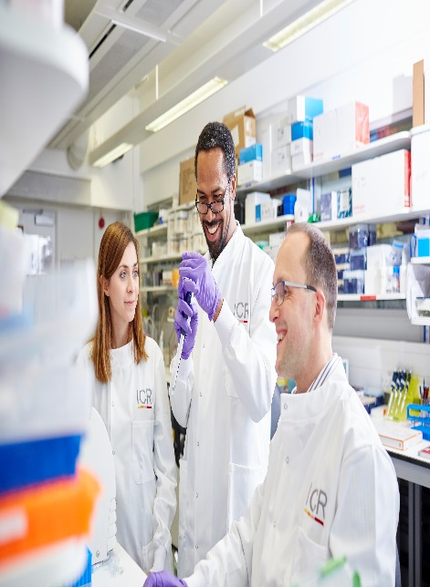

About our organisation

The Institute of Cancer Research, London, is one of the world’s most
influential cancer research institutions with an outstanding track record
of achievement dating back more than 100 years. Our mission is to
make the discoveries that defeat cancer.

As well as being one of the UK’s leading higher education institutions in
research quality and impact, the ICR is consistently ranked as one of
the world’s most successful for industry collaboration. As a member
institution of the University of London, we also provide postgraduate
higher education of international distinction.

We are also a charity and rely on the support of partner organisations,
funders, donors and the general public.

Read more to find out about our history, culture, and achievements, and
how our funders, supporters and partnerships help drive our work.

Our values
The ICR has a highly skilled and committed workforce, with a wide variety of roles, each requiring different skills. But whether you work
as a researcher, or work as part of our corporate team, your work and behaviour is underpinned by these six values. They are what bring us together as one team - as 'One ICR'.







Our values set out how each of us at the ICR, works together to
meet our mission – to make the discoveries that defeat cancer. They summarise our desired behaviours, attitudes and culture –
how we value one another and how we take pride in the work we
do, to deliver impact for people with cancer and their loved ones.”
Professor Kristian Helin
Chief Executive

