Postdoctoral Training Fellow:
AI and Precision Oncology (SMPaeds2)
Candidate Information
January 2026

Department / division: | Dynamical Cell Systems Team  Cell and Molecular Biology Division
Pay grade / staff group: | Postdoctoral Training Fellow
Hours / duration: | Full time (35 hours per week), Monday to Friday. Fixed term contract for 1 year with room for extension
Reports to: | Professor Chris Bakal, Group Leader
Job description

Context
Stratified medicine is transforming cancer care, yet many children and young people with relapsed cancers still lack effective, personalised treatment options. Advances in artificial intelligence (AI) and multimodal data integration now make it possible to extract predictive insight from complex clinical datasets that were previously underutilised.
This role is embedded within SMPaeds2 (Stratified Medicine Paediatrics 2) programme. SMPaeds2 is a national initiative designed to accelerate precision medicine for paediatric cancers by integrating imaging, genomics, and clinical data at scale.
Our mission
is to make the discoveries that defeat cancer.

Main purpose of the job

To develop and apply multimodal AI and machine-learning models that integrate high-content histopathology, genomic sequencing, blood biomarkers, and clinical outcome data to stratify patients with neuroblastoma and predict therapeutic response. The postholder will directly contribute to translating computational discovery into clinical trial assignment, supporting the next generation of precision oncology for children and young people with relapsed cancer.

Further information
You may contact Chris Bakal for further information by emailing chris.bakal@icr.ac.uk. This job description is a reflection of the current position and is subject to review and alteration in detail and emphasis in the light of future changes or development.
Duties and responsibilities

Key duties
Develop, train, and validate deep-learning and computer-vision models for analysis of high-content histopathology and imaging data.
Design and implement multimodal data-fusion approaches, integrating imaging with genomic, molecular, and clinical datasets from the SMPaeds2 programme.
Apply machine-learning models to find patient subtypes and predict therapeutic response in neuroblastoma.
Work closely with clinicians and translational researchers to ensure outputs are clinically interpretable and aligned with trial decision-making.
Maintain robust, reproducible analysis pipelines using best practices in scientific software development.
Accurate documentation of analyses, models, and results using electronic record-keeping systems.
Communicate results clearly within the laboratory, across the SMPaeds2 network, and with clinical collaborators.
Present at seminars, and scientific conferences.
Contribute to the preparation of manuscripts, reports, and grant-related outputs arising from the work.
Work independently while seeking guidance when appropriate, and contribute positively to a multidisciplinary team environment.
Support the training and mentoring of junior researchers and students.
Coordinate with commercial partners and ICR BIO team.

Workforce Agreement for Postdoctoral Training Fellows
The ICR has a workforce agreement stating that Postdoctoral Training Fellows can only be employed for
up to 7 years as PDTF at the ICR, providing total postdoctoral experience (including previous employment
at this level elsewhere) does not exceed 10 years.

General
All staff must ensure that they familiarise themselves with and adhere to any ICR policies that are relevant
to their work and that all personal and sensitive personal data is treated with the utmost confidentiality and
in line with the General Data Protection Regulations.
Any other duties that are consistent with the nature and grade of the post that may be required.
To work in accordance with the ICR’s Values.
To promote a safe, healthy and fair environment for people to work, where bullying and harassment will not be tolerated.
Person specification

Education and Knowledge
 | PhD in Computer Science, Computational Biology, Physics, or related quantitative discipline. | Essential
 | Strong publication record proving application of AI or machine learning to scientific problems. | Desirable
Knowledge of machine learning, deep learning, and computer vision. |  | Essential
Knowledge of cancer biology, genomics, or biomedical data analysis. |  | Desirable

Skills
Ability to design, implement, and evaluate machine-learning models. | Essential
Proficiency in Python and deep-learning frameworks (e.g. PyTorch, TensorFlow). | Essential
Ability to integrate unstructured and structured datasets (e.g. images with genomics/clinical data). | Desirable
Ability to present research at meetings and conferences. | Essential
Strong organisational and time-management skills. | Essential
Ability to work effectively both independently and within multidisciplinary teams. | Desirable
Experience with large-scale biomedical datasets. | Desirable

Experience
Experience applying machine learning to biological or biomedical data. | Essential
Experience with computer vision or image-based analysis. | Essential
Experience working in collaborative, interdisciplinary research environments. | Desirable
Experience in oncology, developmental biology, or precision medicine. | Desirable
Experience working with clinical or translational datasets. | Desirable

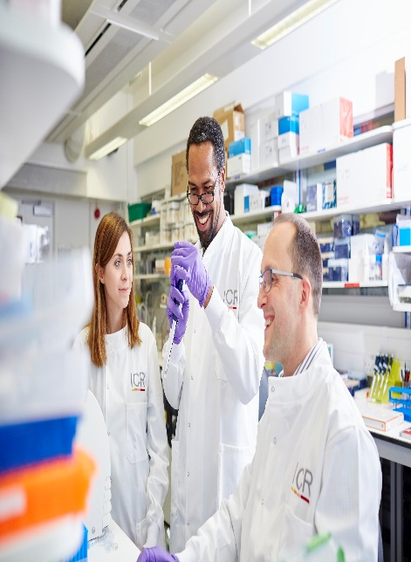
About our organisation

The Institute of Cancer Research, London, is one of the world’s most
influential cancer research institutions with an outstanding track record
of achievement dating back more than 100 years. Our mission is to
make the discoveries that defeat cancer.

As well as being one of the UK’s leading higher education institutions in
research quality and impact, the ICR is consistently ranked as one of
the world’s most successful for industry collaboration. As a member
institution of the University of London, we also provide postgraduate
higher education of international distinction.

We are also a charity and rely on the support of partner organisations,
funders, donors and the general public.

Read more to find out about our history, culture, and achievements, and
how our funders, supporters and partnerships help drive our work.Our values
The ICR has a highly skilled and committed workforce, with a wide variety of roles, each requiring different skills. But whether you work
as a researcher, or work as part of our corporate team, your work and behaviour is underpinned by these six values. They are what bring us together as one team - as 'One ICR'.







Our values set out how each of us at the ICR, works together to
meet our mission – to make the discoveries that defeat cancer. They summarise our desired behaviours, attitudes and culture –
how we value one another and how we take pride in the work we
do, to deliver impact for people with cancer and their loved ones.”
Professor Kristian Helin
Chief Executive

