Business Development Intern
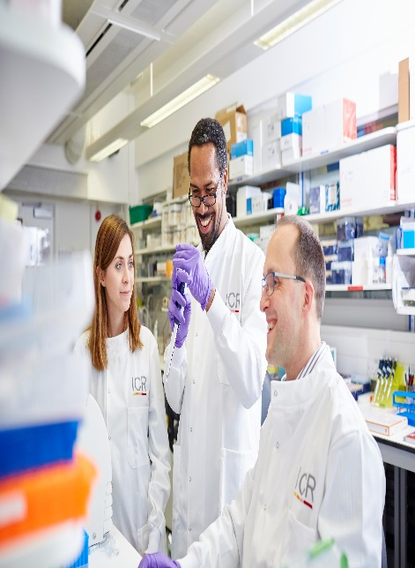

Candidate Information
Date: July 2022

The Institute of Cancer Research

About our organisation
We are one of the world’s most influential cancer research institutes with an outstanding record of achievement dating back more than 100 years. We are world leaders in identifying cancer genes, discovering cancer drugs and developing precision radiotherapy. Together with our hospital partner The Royal Marsden, we are rated in the top four centres for cancer research and treatment worldwide.
As well as being a world-class institute, we are a college of the University of London. We came second overall and top for biological sciences in the most recent Research Excellence Framework (REF 2021 (ref.ac.uk)) a measure of university research quality.
We have charitable status and rely on support from partner organisations, charities, donors and the general public.
We have more than 1000 staff and postgraduate students across three sites – in Chelsea and Sutton.

Business and Innovation Office
The Business and Innovation Office acts as the technology and knowledge transfer hub for The Institute of Cancer Research, providing the experience and expertise to put in place a wide range of agreements between our scientists and industry.
You will be joining one of the most successful teams of its type in the UK. We are a busy team working on a wide variety of projects with many different academic and commercial partners.
Our mission
is to make the discoveries that defeat cancer.

Our values
The ICR has a highly skilled and committed workforce, with a wide variety of roles, each requiring different skills. But whether you work as a researcher, or work as part of our corporate team, your work and behaviour is underpinned by these six values. They are what bring us together as one team - as 'One ICR'.

Pursuing excellence






We aspire to excellence in everything we do, and aim to be leaders in our field.

Acting with Integrity
We promote an open and honest environment that gives credit and acknowledges mistakes, so that our actions stand up to scrutiny.

Valuing all our people
We value the contribution of all our people, help them reach their full potential, and treat everyone with kindness and respect.

Working together
We collaborate with colleagues and partners to bring together different skills, resources and perspectives.

Leading innovation
We do things differently in ways that no one else has done before, and share the expertise and learning we gain.

Making a difference
We all play our part, doing a little bit more, a little bit better, to help improve the lives of people with cancer.


Our values set out how each of us at the ICR, works together to
meet our mission – to make the discoveries that defeat cancer. They summarise our desired behaviours, attitudes and culture –
how we value one another and how we take pride in the work we
do, to deliver impact for people with cancer and their loved ones.”
Professor Kristian Helin
Chief Executive

Department / division: | Business and Innovation Office
Pay grade / staff group: | Professional Services
Hours / duration: | Full time (35 hours per week), Monday to Friday. Fixed term contract for 1 year
Reports to: | Contracts Manger
Main purpose of the job: | To gain experience of working in a technology transfer and knowledge exchange office
Job description
Duties and responsibilities:

Scope

This internship will help you develop skills and experience working in contracts, technology transfer and knowledge exchange, at the interface of academic and industry.
You will be introduced to many aspects of the work of the Business and Innovation Office (BIO) and will have the opportunity to work with different functions within the office.
You will gain; a knowledge of drafting and negotiation of contracts, knowledge of Intellectual Property protection and exploitation, the ability to distil key scientific concepts and communicate these ideas to others, knowledge of key industry areas, ability to analyse market potential and interpersonal skills.
We will provide formal training including the chance to attend Knowledge Exchange UK or UCL training.
You will be expected to work on a range of agreements including material transfer, confidentiality, and data transfer agreement.
There will be the opportunity to shadow BIO managers on more complex projects.
You will be an active member of the BIO and contribute to team meetings.
You will be expected to review your experience at the end of the year and provide material on your experience to be published by ICR.

General

All staff must ensure that they familiarise themselves with and adhere to any ICR policies that are relevant to their work and that all personal and sensitive personal data is treated with the utmost confidentiality and in line with the General Data Protection Regulations
You may be asked to undertake other duties that are consistent with the nature and grade of the post.
You will be expected to work in accordance with the ICR’s Values.
You will be expected to promote a safe, healthy and fair environment for people to work, where bullying and harassment will not be tolerated.
This job description is a reflection of the present position and is subject to review and alteration in detail and emphasis in the light of future changes or development.

Education and Knowledge
A degree in a subject relevant to the ICR or BIO is required | E
High levels of literacy and numeracy | E
A post-graduate qualification | D

Skills
Person specification
Ability to grasp complex concepts quickly | E
Excellent communication skills, both written and verbal | E
Good interpersonal skills at all levels | E
Meticulous attention to detail | E
Excellent IT skills, with the ability to implement, use and maintain computerised and web-based administrative systems and data sources effectively | E
Excellent organisation skills with a demonstrated ability to muti-task, priortise tasks effectively and mange workloads. | E
Ability to work as part of a team and interact with people at all levels | E
Ability to rapidly learn new skills | E
Ability to act on information from lots of different sources | E
Good financial skills | D
An understanding of intellectual property and patent law | D
An ability to negotiate and influence effectively | D
An understanding of commercial and academic agreements | D
Networking Skills | D

Experience
Little of no direct work experience in technology transfer or contracts is required but you must have a passion for innovation and a desire to explore a career in supporting academic research and technology transfer | E
Previous experience in putting in place material transfer or confidentiality agreements or being involved in a research collaboration with a company would be beneficial | D

We offer a fantastic working environment, great opportunities for career development and the chance to make a real difference to defeat cancer. We aim to recruit and develop the best – the most outstanding scientists and clinicians, and the most talented professional and administrative staff.
The annual leave entitlement for full time employees is 28 days per annum on joining. This will increase by a further day after 2 years’ and 5 years' service.
Staff membership to the Universities Superannuation Scheme (USS) is available. The USS is a defined benefit scheme and provides a highly competitive pension scheme with robust benefits. The rate of contributions is determined by USS and details of the costs and benefits of this scheme can be found on their website. If staff are transferring from the NHS, they can opt to remain members of the NHS Pension Scheme.
We offer a range of family friendly benefits such as flexible working, a parents’ group, and a maternity mentoring scheme. Other great benefits include interest free loans for discounted season tickets for travel and bicycle purchases, access to the NHS discounts website, a free and confidential Employee Assistance Programme which offers a range of well-being, financial and legal advice services, two staff restaurants, and access to a gym and sporting facilities at our Sutton site.

Further information
You may contact Yvette Newbatt for further information by emailing yvette.newbatt@icr.ac.uk. This job description is a reflection of the current position and is subject to review and alteration in detail and emphasis in the light of future changes or development.
At the time of writing, professional services staff at the ICR are engaged in a hybrid working trial, with approximately two days a week on site and three working from home.
Benefits

