Postdoctoral Training Fellow:
Integration of functional imaging into Radiotherapy treatment planning
Candidate Information
March 2026

Department / division: | Radiotherapy and Imaging
Pay grade / staff group: | Postdoctoral Training Fellow
Hours / duration: | Full time. Fixed term contract for four years
Reports to: | Head of the Joint Department of Physics
Job description

Context
We are seeking a highly motivated and creative post-doctoral training fellow who is focused on a career in research to join our team. The post-doctoral training fellow will investigate the integration of hypoxia information acquired using MR imaging into our research treatment planning system. The successful candidate will work in an interdisciplinary team of medical physicists, computer scientists and clinicians in the Joint Department of Physics at the Institute of Cancer Research and the Royal Marsden NHS Foundation Trust and be part of a team of post-doctoral research fellows who will work on the clinical implementation of oxygen enhanced MR imaging into clinical practice. She/He will develop a mathematical model to assess the impact of different dose prescription on the overall tumour response and possible dose de-escalation and quality of life improvements to the patient. The model will be integrated into our research treatment planning system and multiple dose delivery strategies explored.

The Radiotherapy Physics Modelling Team is primarily focused on the development and application of novel technology to further radiotherapy treatments. This includes novel treatment planning techniques, the development of new optimisation algorithms and using modern computer hardware to enable real-time online plan optimisation.

The post holder will drive the work forward within a multi-disciplinary team of computer scientists, medical physicists and clinicians in the Joint Department of Physics at the Institute of Cancer Research and the Royal Marsden NHS Foundation Trust. Applicants will hold a PhD in Physics, Engineering or another relevant field and ideally have experience in radiotherapy physics, optimisation algorithms and/or MR imaging.
Our mission
is to make the discoveries that defeat cancer.

Main purpose of the job
Implement biological models that incorporate oxygen enhanced MR imaging for patients undergoing radiotherapy for Head and Neck cancer. Integrate the biological model into our research treatment planning system and develop optimisation algorithms based on the biological model to perform simulation for dose de-escalation treatment approaches. Participate in the development of a prospective study to evaluate the optimal algorithm in a clinical setting. Funding of the post is provided by a CRUK programme of Prof J O’Connor (PI). The focus of this post is on medical radiotherapy physics lead by Prof U Oelfke and the Head of Translational Radiotherapy Physics Simeon Nill, PhD.

Further information
You may contact Prof Uwe Oelfke (uwe.oelfke@icr.ac.uk) and Simeon Nill (simeon.nill@icr.ac.uk) for further information. This job description is a reflection of the current position and is subject to review and alteration in detail and emphasis in the light of future changes or development.
Duties and responsibilities

Key duties
Develop a framework for biological optimisation of treatment plans using oxygen enhanced MR images.
Support the development of a clinical trial to evaluate the impact of oxygen enhanced MR images on Head & Neck patients.
Maintain and further improve the currently available tool set for our in-house research treatment planning software.
Provide evidence (using phantoms and data acquired from patients with oxygen enhanced MR imaging) to demonstrate that the optimised treatment plan can be safely delivered to future patients.
Mentor scientific staff, e.g. PhD students and undergraduates, in research projects related to radiotherapy. Support other team members in their research by engaging with their work and promoting a positive research ethos.
Publish the results of the research in peer reviewed journals and present at national and international conferences
Work in collaboration with other research members of the CRUK program grant
Keep up to date with, and inform the team of, new developments in the relevant literature.
Ensure adequate record-keeping and documentation of all experiments and developed source code.
Carry out the above functions in accordance with the policies of the Institute of Cancer Research and where appropriate, the Royal Marsden NHS Foundation Trust.

Workforce Agreement for Postdoctoral Training Fellows
The ICR has a workforce agreement stating that Postdoctoral Training Fellows can only be employed for
up to 7 years as PDTF at the ICR, providing total postdoctoral experience (including previous employment
at this level elsewhere) does not exceed 10 years.

General
All staff must ensure that they familiarise themselves with and adhere to any ICR policies that are relevant
to their work and that all personal and sensitive personal data is treated with the utmost confidentiality and
in line with the General Data Protection Regulations.
Staff are expected to carry out any other duties that are consistent with the nature and grade of the post that may be required.
All staff must work in accordance with the ICR’s Values.
Staff should promote a safe, healthy and fair environment for people to work, where bullying and harassment will not be tolerated.

Person specification

Education and Knowledge
 | PhD* in Physics, Engineering, Informatics or a related discipline | Essential
 | Knowledge of radiotherapy physics, treatment planning, programming, relevant experimental methodology. | Essential
Basic understanding of Radiobiology |  | Desirable

Skills
Ability to assimilate relevant information and initiate new areas of research | Essential
Coordinating, planning and executing research to a high standard. | Essential
Good communication skills and the ability to foster collaborative projects. | Essential
Experience with at least one high level programming language like C or C#. | Essential

Experience
Radiotherapy treatment planning and optimisation algorithms | Essential
Proven track record of productive research/good publication record | Essential
Familiarity with radiotherapy treatment workflows | Desirable
Development and application of research software | Desirable

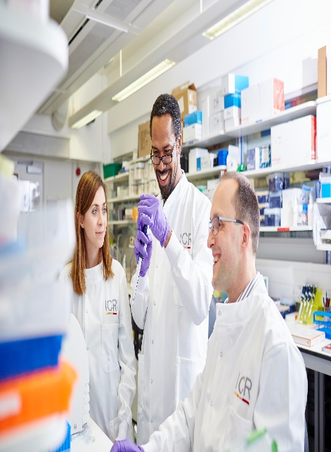
About our organisation

The Institute of Cancer Research, London, is one of the world’s most
influential cancer research institutions with an outstanding track record
of achievement dating back more than 100 years. Our mission is to
make the discoveries that defeat cancer.

As well as being one of the UK’s leading higher education institutions in
research quality and impact, the ICR is consistently ranked as one of
the world’s most successful for industry collaboration. As a member
institution of the University of London, we also provide postgraduate
higher education of international distinction.

We are also a charity and rely on the support of partner organisations,
funders, donors and the general public.

Read more to find out about our history, culture, and achievements, and
how our funders, supporters and partnerships help drive our work.

Our values
The ICR has a highly skilled and committed workforce, with a wide variety of roles, each requiring different skills. But whether you work
as a researcher, or work as part of our corporate team, your work and behaviour is underpinned by these six values. They are what bring us together as one team - as 'One ICR'.







Our values set out how each of us at the ICR, works together to
meet our mission – to make the discoveries that defeat cancer. They summarise our desired behaviours, attitudes and culture –
how we value one another and how we take pride in the work we
do, to deliver impact for people with cancer and their loved ones.”
Professor Kristian Helin
Chief Executive

