Scientific Officer/Higher Scientific Officer
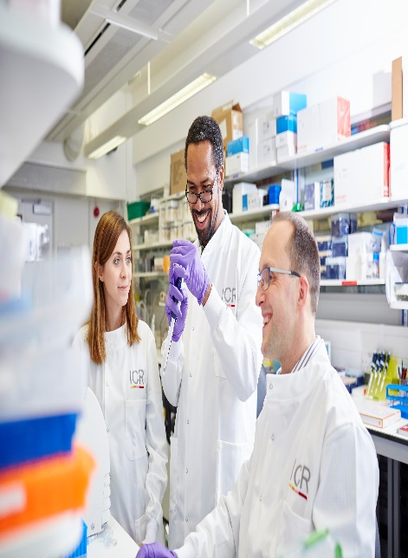

Drug Metabolism and Pharmacokinetics

Candidate Information

January 2026

The Institute of Cancer Research

About our organisation
We are one of the world’s most influential cancer research institutes with an outstanding record of achievement dating back more than 100 years. We are world leaders in identifying cancer genes, discovering cancer drugs and developing precision radiotherapy. Together with our hospital partner The Royal Marsden, we are rated in the top four centres for cancer research and treatment worldwide. As well as being a world-class institute, we are a college of the University of London.
We came second in the league table of university research quality compiled from the Research Excellence Framework (REF 2021). We have charitable status and rely on support from partner organisations, charities, donors and the general public. We have more than 1000 staff and postgraduate students across three sites – in Chelsea and Sutton.

Centre for Cancer Drug Discovery at the ICR
The Centre for Cancer Drug Discovery (CCDD) is a multidisciplinary 'bench to bedside' centre, comprising around 150 staff dedicated to the discovery and development of novel therapeutics for the treatment of cancer. The CCDD’s exciting goal is to discover high quality drug candidates for validated biological targets and to progress these candidates to clinical trial. All the scientific disciplines are in place to make this possible. Our biologists work alongside world-class chemists and DMPK (drug metabolism and pharmacokinetics) specialists focusing on new molecular targets emerging from human genome and ground-breaking cell biology research.
This is an exciting and fast-moving area of cancer research and offers the opportunity to work within a multi-disciplinary environment using state-of-the-art techniques and equipment.

About the team

The DMPK team evaluates the metabolism and pharmacokinetics of novel anticancer drugs. We carry out state of the art assays to support the preclinical and clinical development of novel agents across our portfolio and use mass spectrometry to characterise absorption, distribution, metabolism and excretion (ADME) of small molecules. Working closely with biologists, we assess pharmacokinetic-pharmacodynamic relationships to optimise scheduling for proof-of-concept studies. We predict pharmacokinetics (PK) and dose to man and carry out the PK analysis in first in human studies at the Royal Marsden Hospital.

About the position

The post holder will be based in the Drug Metabolism and Pharmacokinetics (DMPK) team. The key role is to support pre-clinical drug discovery projects. The post holder will work with other members of the team to evaluate the pharmacokinetics and metabolism of potential new anticancer drugs. The post holder will develop, validate, run and report in-vitro DMPK assays and perform in-vivo bioanalysis in line with Good Clinical Practice (GCP) guidelines to measure compounds of various modalities and identify metabolites in preclinical samples. The role involves extensive use of Liquid Chromatography-Mass Spectrometry (LC-MS) methodology. The post holder will also interpret analytical data using PK software to calculate pharmacokinetic parameters. Additionally, the candidate will be required to collate, interpret data and report results to both internal project teams and external collaborators.

Department / division: | Drug Metabolism and Pharmacokinetics (DMPK), Centre for Cancer Drug Discovery, Division of Cancer Therapeutics
Pay grade / staff group: | Scientific Professional Grade 7-5. Depending on relevant skills and experience and post appointment
Hours / duration: | Full time (35 hours per week), Monday to Friday.  Fixed term contract until Sept. 2027
Reports to: | Angela Hayes/Ruth Ruddle
Main purpose of the job: | Drug Metabolism and Pharmacokinetics  Scientific Officer/Higher Scientific Officer
Job description

Key duties and responsibilities

To develop analytical methods to measure compounds in various matrices including biological tissues and fluids
To perform DMPK assays and analyse samples from in vitro drug metabolism and pharmacokinetic screens
To perform data analysis and interpretation of DMPK studies
To develop and optimise novel in-vitro assays
To report results internally and with collaborators
To work within the guidelines of Data Protection and Good Clinical Practice

Laboratory management

To become familiar with the use and maintenance of laboratory equipment (LC-MS, liquid handling systems and general laboratory)
Ensure that work conforms to safety and regulatory requirements
To become familiar with Standard Operating Procedures (SOP’s)
To contribute to laboratory tasks ensuring compliance
To negotiate and maintain laboratory supplies
Laboratory housekeeping

General

To communicate effectively with other members of the team, the Centre for Drug Discovery, and external collaborators
To keep accurate records of the work in electronic laboratory notebooks, collate and report results
To work effectively in a team environment
To work in a flexible manner and be organised, meeting objectives and deadlines
To ensure familiarisation and adherence to any ICR policies that are relevant to their work and that all personal and sensitive personal data is treated with the utmost confidentiality and in line with the General Data Protection Regulations
To work in accordance with the ICR’s Values
To promote a safe, healthy and fair environment for people to work, where bullying and harassment will not be tolerated
Any other duties that are consistent with the nature and grade of the post that may be required
This job description is a reflection of the present position and is subject to review and alteration in detail and emphasis in the light of future changes or development

Education and Knowledge

BSc (Pharmacology/Toxicology, Analytical Chemistry or a related subject) | Essential
Knowledge of LCMS techniques | Desirable
Knowledge of pharmacology/pharmacokinetics | Desirable

Skills
Person specification
Effective Communication | Essential
Flexibility | Essential
Ability to work within the guidelines of Data Protection and Good Clinical Practice | Essential
Good computational skills, including knowledge of Excel | Essential
Enthusiasm to work in an interdisciplinary environment towards the goal of developing improved cancer therapeutics | Essential
Ability to problem solve and troubleshoot efficiently | Essential
Attention to detail and keeping appropriate records | Essential
Ability to work effectively & efficiently, both independently & as part of a team | Essential

Experience
Laboratory experience preferably DMPK or analytical | Essential
Experience of LCMS techniques | Desirable
Performing in-vitro DMPK/ADME assays | Desirable
Experience of in-vitro DMPK assay development | Desirable
Experience of in-vivo bioanalysis | Desirable
Performing pharmacokinetic analysis | Desirable
Cell culture | Desirable
Drug development | Desirable

We offer a fantastic working environment, great opportunities for
career development and the chance to make a real difference to defeat cancer. We aim to recruit and develop the best – the most outstanding scientists and clinicians, and the most talented professional and administrative staff.
Benefits
Contract term: The position is offered on a fixed-term contract until 30th September 2027 in the first instance.
Salary: Starting salary is in the range of £31,445 - £41,900 per annum depending on experience.
Annual Leave: The annual leave entitlement for full time employees is 28 days per annum on joining. This will increase by a further day after 2 years’ and 5 years' service.
Pension: Staff membership to the Universities Superannuation Scheme (USS)
is available. The USS is a defined benefit scheme and provides a
highly competitive pension scheme with robust benefits. The rate of contributions is determined by USS and details of the costs and benefits of this scheme can be found on their website. If staff are transferring from the NHS, they can opt to remain members of the NHS Pension Scheme.
Other Benefits: We offer a range of family friendly benefits such as flexible working,
a parents’ group, and a maternity mentoring scheme. Other great benefits include interest free loans for discounted season tickets for travel and bicycle purchases, access to the NHS discounts website,
a free and confidential Employee Assistance Programme which offers
a range of well-being, financial and legal advice services, two staff restaurants, and access to a gym and sporting facilities at our
Sutton site.

Further information
You may contact us for further information by emailing angela.hayes@icr.ac.uk or ruth.ruddle@icr.ac.uk. This job description is a reflection of the current position and is subject to review and alteration in detail and emphasis in the light of future changes or development.

Our values
The ICR has a highly skilled and committed workforce, with a wide variety of roles, each requiring different skills. But whether you work as a researcher, or work as part of our corporate team, your work and behaviour is underpinned by these six values. They are what bring us together as one team - as 'One ICR'.

Pursuing excellence






We aspire to excellence in everything we do and aim to be leaders in our field.

Acting with Integrity
We promote an open and honest environment that gives credit and acknowledges mistakes, so that our actions stand up to scrutiny.

Valuing all our people
We value the contribution of all our people, help them reach their full potential, and treat everyone with kindness and respect.

Working together
We collaborate with colleagues and partners to bring together different skills, resources and perspectives.

Leading innovation
We do things differently in ways that no one else has done before and share the expertise and learning we gain.

Making a difference
We all play our part, doing a little bit more, a little bit better, to help improve the lives of people with cancer.


Our values set out how each of us at the ICR, works together to meet our mission – to make the discoveries that defeat cancer. They summarise our desired behaviours, attitudes and culture – how we value one another and how we take pride in the work we do, to deliver impact for people with cancer and their loved ones.”

Professor Kristian Helin
Chief Executive

