Clinical Research Fellow
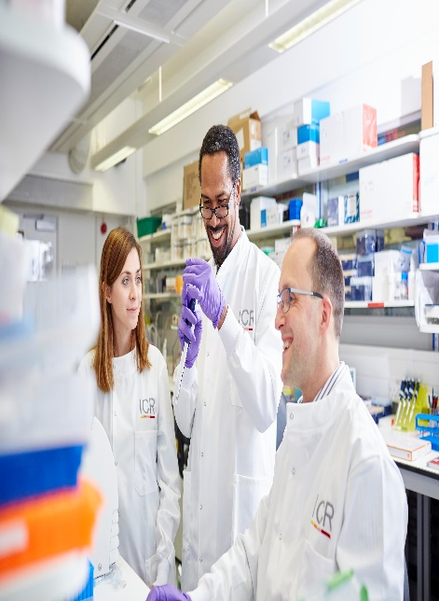

Candidate Information
March 2026

The Institute of Cancer Research (ICR)

About our organisation
We are one of the world’s most influential cancer research institutes with an outstanding record of achievement dating back more than 100 years. We are world leaders in identifying cancer genes, discovering cancer drugs and developing precision radiotherapy. Together with our hospital partner The Royal Marsden, we are rated in the top four centres for cancer research and treatment worldwide.
As well as being a world-class institute, we are a college of the University of London. We came top in the league table of university research quality compiled from the Research Excellence Framework (REF 2014).
We have charitable status and rely on support from partner organisations, charities, donors and the general public.
We have more than 1000 staff and postgraduate students across three sites – in Chelsea and Sutton.

Prostate Cancer Targeted Therapy Group (PCTTG), Clinical Studies Division
The PCTTG, under the leadership and guidance of Professor Johann de Bono and Drs Adam Sharp and Alec Paschalis, has led on the development of many of the new drugs currently used for the management of advanced prostate cancer including abiraterone, cabazitaxel, enzalutamide, olaparib and Lutetium PSMA. The Unit is based in Sutton at the Royal Marsden in the Oak Cancer Centre, a day-care area with outpatient facilities exclusively dedicated to the care and treatment of patients enrolled in clinical trials and is closely linked to our translational research laboratories at the ICR.
Our mission
is to make the discoveries that defeat cancer.

Our values
The ICR has a highly skilled and committed workforce, with a wide variety of roles, each requiring different skills. But whether you work as a researcher, or work as part of our corporate team, your work and behaviour is underpinned by these six values. They are what bring us together as one team - as 'One ICR'.

Pursuing excellence






We aspire to excellence in everything we do, and aim to be leaders in our field.

Acting with Integrity
We promote an open and honest environment that gives credit and acknowledges mistakes, so that our actions stand up to scrutiny.

Valuing all our people
We value the contribution of all our people, help them reach their full potential, and treat everyone with kindness and respect.

Working together
We collaborate with colleagues and partners to bring together different skills, resources and perspectives.

Leading innovation
We do things differently in ways that no one else has done before, and share the expertise and learning we gain.

Making a difference
We all play our part, doing a little bit more, a little bit better, to help improve the lives of people with cancer.

Department / division:  Job description | PCTTG, Division of Clinical Studies, Sutton
Pay grade / staff group: | Clinical Research Fellow
Hours / duration: | Full time (40 hours per week), Monday to Friday. Fixed term contract for 1 year in the first instance.
Reports to: | Professor Johann de Bono
Main purpose of the job: | This Clinical Research Fellowship with the Prostate Cancer Targeted Therapy Group at The ICR provides clinical academics with the expertise to discover, develop and deliver the next generation of treatments, technologies and methodology into clinical care. The candidate will undertake basic laboratory and translational research under the expert supervision of Professor de Bono, Drs Adam Sharp and Alec Paschalis, and other senior scientists within the Cancer Biomarkers Group. The candidate will participate in the highly successful translational research culture of the ICR and The Royal Marsden NHS Foundation Trust. The candidate will then have the opportunity to deliver their research findings to the clinic through the design of early phase clinical trials conducted at the Drug Development Unit (DDU)– Prostate Cancer Targeted Therapies Group and other collaborating centres.  Clinicians on this prestigious training programme will also benefit from:  - Mentoring from a senior clinical academic to support the transition between clinical training and research.  - A full programme of training tailored to the needs of the individual, including statistics, research methods, bioinformatics, laboratory skills, research integrity, academic writing and flexibly-delivered online training including Research Clinician and Perspectives in Oncology.  - Access to our bespoke Clinical Academic Career Development programme, run through the ICR/RMH Biomedical Research Centre.  - The ICR/RMH flagship Pathway to Independence - Clinical Academics in Cancer Research residential programme, providing intensive coaching to prepare you for academic independence and applications for clinician scientist awards.

Duties and responsibilities:

Responsibilites

- The job will consist of both clinical and translational laboratory work, with this being shared by a team of medical, nursing, laboratory and other staff.
- As a member of the team the Fellow will be called upon to assist in the day-to-day management of patients involved in studies, this includes outpatient clinics and care of in-patients as required.
- Satisfactory accrual of patients into studies, i.e. selection, screening and initial counselling.
- Obtaining informed consent and undertaking patient support.
- Liaison between laboratory investigators and hospital staff.
- Liaison with study monitors, from both pharmaceutical companies and Cancer Research UK.
- Assistance with completion of Case Record Forms.
- Assistance in maintaining an efficient and tidy laboratory.
- Undertaking any honorary clinical duties covered under an Honorary Contract with the RMH.

General

- To work in a flexible, but organized manner.
- To meet objectives within predetermined timescales.
- To communicate effectively with other members of the group, the Drug Development Unit (DDU), Prostate Cancer Targeted Therapy Group (PCTTG) and The Institute, and where necessary outside organizations.
- To take an interest in the relevant literature and assess and implement developments in molecular biology procedures as appropriate.
- All staff must ensure that they familiarise themselves with and adhere to any ICR policies that are relevant to their work and that all personal and sensitive personal data is treated with the utmost confidentiality and in line with the General Data Protection Regulations.
- Any other duties that are consistent with the nature and grade of the post that may be required.
- To work in accordance with the ICR’s Values.
- To promote a safe, healthy and fair environment for people to work, where bullying and harassment will not be tolerated.
- This job description is a reflection of the present position and is subject to review and alteration in detail and emphasis in the light of future changes or development.

Confidentiality

- All information concerning patients and staff must be held in the strictest confidence and may not be divulged to any unauthorised person at any time, unless to do so is in the best interest of the individual. In this instance a Senior Team Member would appropriately advise the post holder.
- Computer data should only be accessed if this has been authorised and is necessary as part of your work.
- The post holder must abide by the requirements of the Data Protection Act at all times.

Education and Qualifications
Fully qualified medical oncologist who has completed general medical and medical oncology specialist training, including MRCP or equivalent. | Essential
Appropriate medical qualification (MD or MBBS). | Essential
Basic laboratory research experience (e.g. B Med Sci or B Sci). | Desirable

Experience and Knowledge
Person specification
Experience in treating patients with advanced prostate cancer as well as other malignancies using both standard-of-care therapies and on clinical trials in academic and community settings. | Essential
Excellent general oncological knowledge, knowledge of current prostate cancer literature and prostate cancer biology with preferably some understanding of prostate cancer immune biology. | Essential
Experience in the design and conduct of investigator-initiated early phase (phase 1/2) clinical trials and prostate cancer clinical trials in a cancer clinical trials unit. | Essential
Experience in the conduct and management of industry-initiated phase 1 to 3 clinical trials; experience in liaising with study monitors, pharmaceutical companies and academic sponsors. | Essential
Training in clinical trials methodology and design, an understanding of adaptive clinical trial designs is preferred. | Essential
Experience in analysing clinical data with a basic knowledge in clinical biostatistics. | Desirable
Presentation and/or publication of prostate cancer clinical research and/or translational research in peer-reviewed journals and at national or international conferences. | Essential
Experience in reporting and writing up clinical trial and research data, demonstrated by a publication record. | Essential
Experience in grant writing. | Essential

General
Meeting all conditions required to obtain a Royal Marsden Honorary Contract. | Essential
Ability to work as part of a team. | Essential
Good communication skills. | Essential
Taking initiative and making decisions. | Essential

Benefits
We offer a fantastic working environment, great opportunities for
career development and the chance to make a real difference to defeat cancer. We aim to recruit and develop the best – the most outstanding scientists and clinicians, and the most talented professional and administrative staff.
The annual leave entitlement for full time employees is 28 days per annum on joining. This will increase by a further day after 2 years’ and
5 years' service.
Staff membership to the Universities Superannuation Scheme (USS)
is available. The USS is a defined benefit scheme and provides a
highly competitive pension scheme with robust benefits. The rate of contributions is determined by USS and details of the costs and benefits of this scheme can be found on their website. If staff are transferring from the NHS, they can opt to remain members of the NHS Pension Scheme.
We offer a range of family friendly benefits such as flexible working,
a parents’ group, and a maternity mentoring scheme. Other great benefits include interest free loans for discounted season tickets for travel and bicycle purchases, access to the NHS discounts website,
a free and confidential Employee Assistance Programme which offers
a range of well-being, financial and legal advice services, two staff restaurants, and access to a gym and sporting facilities at our
Sutton site.

Further information
You may contact Johann de Bono for further information by emailing johann.debono@icr.ac.uk This job description is a reflection of the current position and is subject to review and alteration in detail and emphasis in the light of future changes or development.

