Scientific Officer –Myeloma Biology and Therapeutics

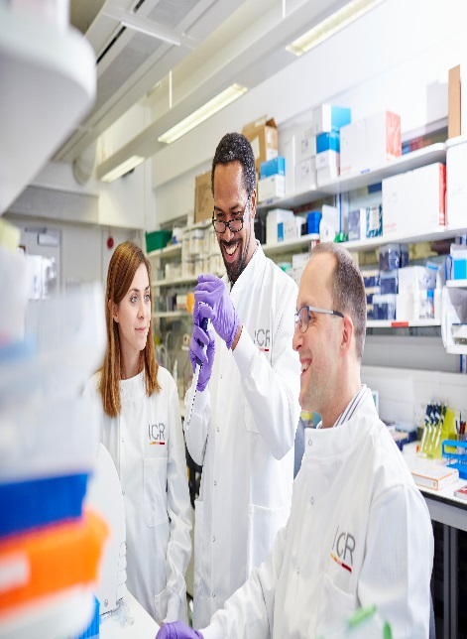

Candidate Information

October 2025

# The Institute of Cancer Research

#### About our organisation

We are one of the world’s most influential cancer research institutes with an outstanding record of achievement dating back more than 100 years. We are world leaders in identifying cancer genes, discovering cancer drugs and developing precision radiotherapy. Together with our hospital partner The Royal Marsden, we are rated in the top four centres for cancer research and treatment worldwide.

As well as being a world-class institute, we are a college of the University of London. We came top in the league table of university research quality compiled from the Research Excellence Framework (REF 2014).

We have charitable status and rely on support from partner organisations, charities, donors and the general public.

We have more than 1000 staff and postgraduate students across three sites – in Chelsea and Sutton.

## Myeloma Biology and Therapeutics Team

Dr Charlotte Pawlyn's team focuses on identifying and validating therapeutic targets for the treatment of immunomodulatory drug resistant and high-risk multiple myeloma. Immunomodulatory drugs are the “prototype” of targeted protein degradation. Myeloma is a bone marrow cancer and the second most common haematological malignancy. Outcomes for patients have improved over the last few decades following the introduction of proteasome inhibitors and immunomodulatory agents. However, patients almost all inevitably relapse and understanding the mechanisms of resistance to these commonly used agents is key to improving outcomes.

## About the Scientific Officer position

The post holder will be based within the Myeloma Biology and Therapeutics Team. They will lead on the isolation of myeloma cells from patient samples and downstream processing, experiments and storage. Additionally the SO will support a range of ongoing molecular and cell biology experiments using cell lines and primary samples within the team, including cell viability assays, flow cytometry, qPCR and Western blotting. There will be opportunities to gain experience in novel techniques and explore new avenues of research.

​

Our mission  
is to make the discoveries that defeat cancer.

Our mission  
is to make the discoveries that defeat cancer.

# Our values

The ICR has a highly skilled and committed workforce, with a wide variety of roles, each requiring different skills. But whether you work as a researcher, or work as part of our corporate team, your work and behaviour is underpinned by these six values. They are what bring us together as one team - as 'One ICR'.

## Pursuing excellence













We aspire to excellence in everything we do, and aim to be leaders in our field.

## Acting with Integrity

We promote an open and honest environment that gives credit and acknowledges mistakes, so that our actions stand up to scrutiny.

## Valuing all our people

We value the contribution of all our people, help them reach their full potential, and treat everyone with kindness and respect.

## Working together

We collaborate with colleagues and partners to bring together different skills, resources and perspectives.

## Leading innovation

We do things differently in ways that no one else has done before, and share the expertise and learning we gain.

## Making a difference

We all play our part, doing a little bit more, a little bit better, to help improve the lives of people with cancer.



***Our values set out how each of us at the ICR, works together to  
meet our mission – to make the discoveries that defeat cancer.*** *They summarise our desired behaviours, attitudes and culture –  
how we value one another and how we take pride in the work we  
do, to deliver impact for people with cancer and their loved ones.”*

**Professor Kristian Helin**

**Chief Executive**

|  |  |
| --- | --- |
| **Department / division:** | Cancer Therapeutics |
| **Pay grade / staff group:** | Scientific Professional |
| **Hours / duration:** | Full time (35 hours per week), Monday to Friday. Fixed term contract for 1 year with the possibility to extend dependant on further funding. |
| **Reports to:** | Dr Charlotte Pawlyn, Group Leader |
| **Main purpose of the job:** | To lead myeloma patient sample processing, storage and culture in line with HTA requirements and good laboratory practice within the Myeloma Biology and Therapeutics Team. To support a wide range of molecular and cell biology experiments within the team. |

Job description

Key Duties and Responsibilities

|  |
| --- |
| Lead on the isolation of myeloma cells from patient samples and downstream processing, experiments and storage in line with HTA requirements and good laboratory practice |
| Follow and establish robust SOPs for tissue culture, cellular and biochemical assays for relevant projects |
| Design and execute cell proliferation, RT-PCR, Western blotting and flow cytometry experiments |
| Assist with the execution of genome editing, compound screening and other experiments in collaboration with other staff members as needed |
| Work in a flexible but organised manner to meet objectives/deadlines and be able to sequentially work on different projects |
| Ensure accurate recording, analysis and interpretation of data, in collaboration with the Team Leader |
| Take an interest in the general literature including scientific papers relevant to the work of the team and effectively ensure discussion with other team members including presentation of results |
| Maintain accurate records in laboratory notebooks and maintain, audit and backup databases of clinical samples and results |
| Initiate purchase of consumable items and minor equipment within budgetary limits |

General

|  |
| --- |
| All staff must ensure that they familiarise themselves with and adhere to any ICR policies that are relevant to their work and that all personal and sensitive personal data is treated with the utmost confidentiality and in line with the General Data Protection Regulations |
| Any other duties that are consistent with the nature and grade of the post that may be required. |
| To work in accordance with the ICR’s Values. |
| To promote a safe, healthy and fair environment for people to work, where bullying and harassment will not be tolerated. |
| This job description is a reflection of the present position and is subject to review and alteration in detail and emphasis in the light of future changes or development. |

Occupational Health

Hepatitis B immunisation will be required for the role and can be arranged through the Institute’s Occupational Health Department prior to appointment.

# Education and Knowledge

|  |  |
| --- | --- |
| First degree in a biological science (1st or 2:1) | Essential |
| MSc/MRes/PhD in biological/biochemical sciences or equivalent experience | Desirable |
| Knowledge of Cell Biology | Essential |
| Knowledge of Haematological malignancies | Desirable |

Skills

Person specification

|  |  |
| --- | --- |
| Strong intellectual curiosity and commitment to successfully learn new research methodologies | Essential |
| Ability to work within the guidelines of Data Protection, Good Laboratory Practice and Good Clinical Practice | Essential |
| Basic computational biology skills and database use | Essential |
| Attention to detail and keeping appropriate records | Essential |
| Ability to meet deadlines whilst multitasking under pressure | Essential |
| Professional presentation skills with the ability to recognise and highlight key information | Essential |
| Ability to work effectively & efficiently, both independently & as part of a team | Essential |
| Enthusiasm to work in an interdisciplinary environment towards the goal of developing improved cancer therapeutics | Essential |
| Track record of completing projects and preparing reports/presentations/scientific papers | Desirable |

Experience

|  |  |
| --- | --- |
| Cell culture | Essential |
| Cell/molecular biology and biochemistry techniques | Essential |
| Working with clinical samples | Desirable |

We offer a fantastic working environment, great opportunities for  
career development and the chance to make a real difference to defeat cancer. We aim to recruit and develop the best – the most outstanding scientists and clinicians, and the most talented professional and administrative staff.

The annual leave entitlement for full time employees is 28 days per annum on joining. This will increase by a further day after 2 years’ and  
5 years' service.

Staff membership to the Universities Superannuation Scheme (USS)  
is available. The USS is a defined benefit scheme and provides a  
highly competitive pension scheme with robust benefits. The rate of contributions is determined by USS and details of the costs and benefits of this scheme can be found on their website. If staff are transferring from the NHS, they can opt to remain members of the NHS Pension Scheme.

We offer a range of family friendly benefits such as flexible working,  
a parents’ group, and a maternity mentoring scheme. Other great benefits include interest free loans for discounted season tickets for travel and bicycle purchases, access to the NHS discounts website,  
a free and confidential Employee Assistance Programme which offers  
a range of well-being, financial and legal advice services, two staff restaurants, and access to a gym and sporting facilities at our  
Sutton site.

## Further information

You may contact Dr Charlotte Pawlyn for further information by emailing charlotte.pawlyn@icr.ac.uk. This job description is a reflection of the current position and is subject to review and alteration in detail and emphasis in the light of future changes or development.

Benefits